# Build 82 New Features and relevant Information

We have recently launched a new version of Keyhouse (SAM5, also known as Keyhouse New Framework). Build 82 is a prerequisite for the installation of Keyhouse New Framework.

In addition, Build 82 includes a number of new features and improvements, as listed below:

## Reports

Closed Matters as at Date: this report can now be exported to Excel, Word and PDF using the **Queries** menu in SAM.

The following reports can all be exported to Excel, Word and PDF by selecting **Reports | Crystal Reports**:

* Dictation Reports
* Exception Reports
* Fees Received Reports
* SAM Reports including the Trial Balance, Transfer for Costs, Nominal Expenses reports and Nominal Ledger reports
* Profitability Reports: two new reports, Charge Rates and Bills Profitability, have been added to the existing reports showing profitablilty by Client and Department.
* File Manager reports are available by Client, ItemCode and Itemtype.

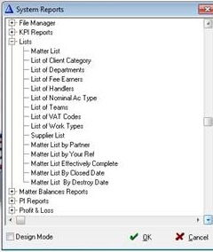Lists: This is a menu of lists, including Suppliers, Clients, Departments and Work Types among others. All lists can be exported to Excel, Word and PDF. To access any of them, select **Reports | Crystal Reports** and then **Lists**.

## Desktop:

New Matter Wizard: We have resolved an issue with the Add Matter Wizard. As before, you may search for an existing client by entering a search term in thesearch box and clicking **Go**. If an existing client matches the search term, its name will be highlighted. Previously, if you clicked **Next** without first selecting the matching client name, the new case would be created for the first client on the list, not for the client shown in the search result. Now the matching client will be selected, even if you do not click its name before clicking Next.

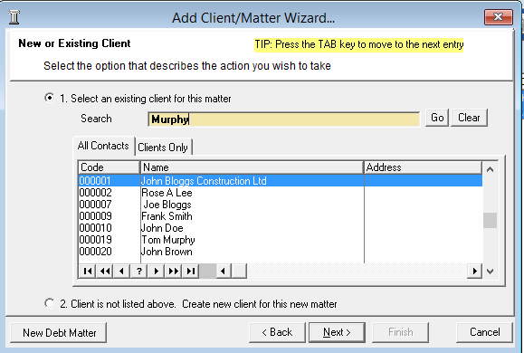

## SAM Accounts

Matter Ledger comments: The comments are now easier to read when the comment line is selected.

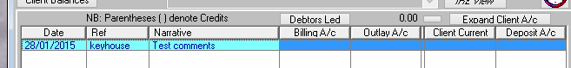

Invoices and Credit Notes: As more and more people are using Time Recording and Billing we have made a change to the field **Bill No**, which will now accept numeric values only. This makes is easier to write time and outlay back to a matter.

