Chapter 1: Getting Started

## Opening Case Management

1. ***Double Click*** the Keyhouse Desktop shortcut on your Desktop.

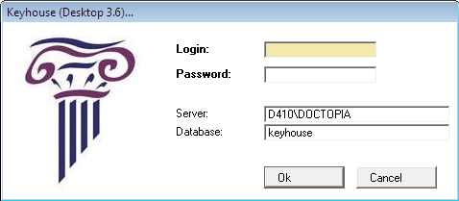

1. The following ***login screen*** will appear.
2. ***Input*** your User Name and Password and click ***OK***.
3. The following screen will appear displaying your task list.

