Chapter 11: The File Manager

## What is the File Manager?

The File Manager is a program that is used to keep track of physical items such as wills, deeds, tapes, share registrations etc. it records details of the physical storage location of the item, which client owns the item and which case it is connected to.

It also tracks the item by recording details on the date the item has been withdrawn and when it has been returned and by whom. The history of the item is also recorded for tracking purposes.

## How to Open File Manager

1. 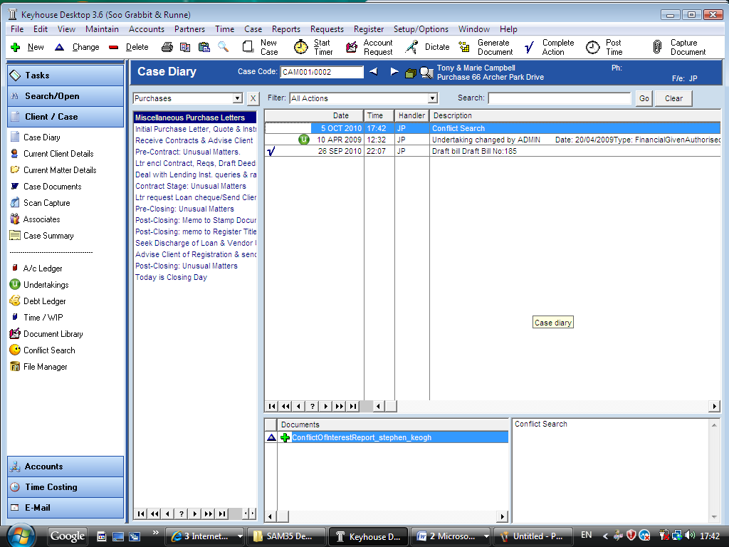***Open*** the required case in the case diary.
2. There is a shortcut to ***File Manager*** available on the ***Case Diary Shortcut*** ***Bar***.
3. Click on ***File Manager*** the following dialogue box will appear.

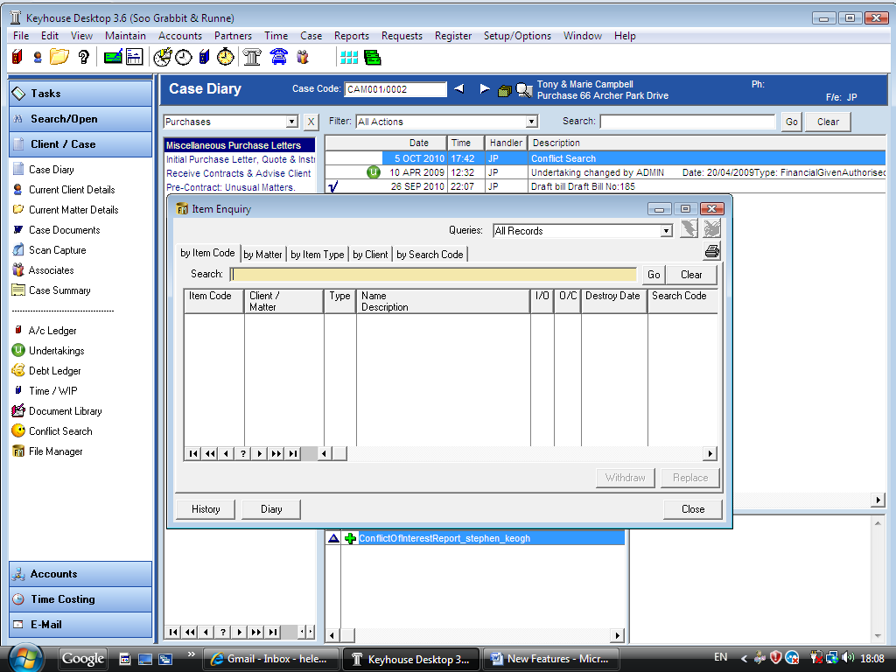

## How to Search for an Item

1. Open the file manager
2. 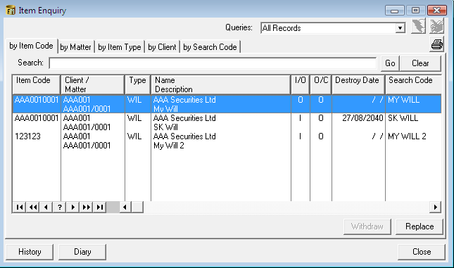***Click*** in the Search box provided.
3. ***Input*** the key search words and click ***Go***. A list of items matching your criteria will be displayed in the window below.
4. Click ***Clear*** to return all items.

## How to Withdraw an Item

1. 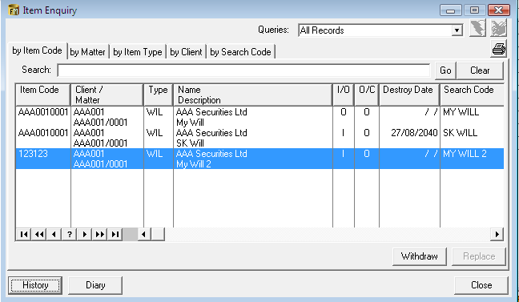Open the file manager, search and select the item you want to withdraw.
2. Click on the ***withdrawn button***. 

**Note** if the withdraw button is greyed out the item is already checked out.

1. The system will ask for your ***password***. Input your ***username*** and ***password***.
2. 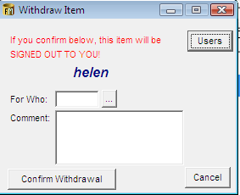A Withdraw Item dialogue box will appear.

***Input*** the following information:

**For Who**

Click on the  ***...lookup button*** and select who the item is for.

**Comment**

***Input*** a comment as why the item is being withdrawn.

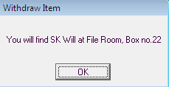

1. Click ***Confirm*** ***Withdrawal***. The following screen will appear telling you where to find the item.

1. Click ***OK.***

## How to Replace an Item

1. Open the ***file manager***, search and select the item you want to replace.
2. Click on the ***Replace button***. 

**Note** if the replace button is greyed out the item is checked in.

1. 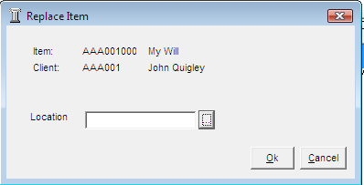 A replace item dialogue box will appear.
2. Click on the  ***... lookup button***. A list of locations will appear.
3. ***Select*** the required location.

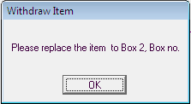

1. Click ***OK***. A message will appear asking you to physically put the item in the selected location.
2. Click ***OK*** the item is now replaced.

## How to Insert an Item in the File Manager

1. 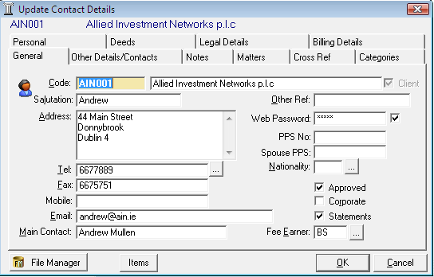In the ***Case Diary*** open the required matter
2. Click on ***Current Client Details***  located on the ***Case diary shortcut bar***.
3. The following dialogue box will appear.
4. Click on the ***Items***  the following screen will appear.

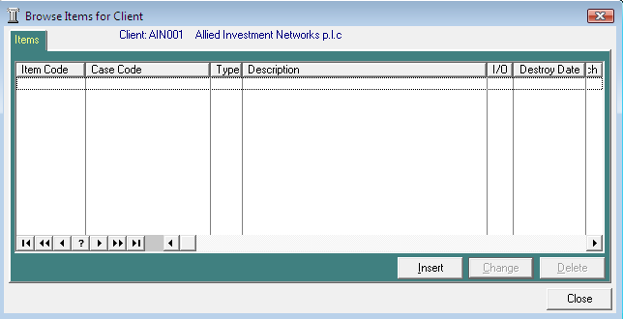

1. Click on the ***Insert***  . The following screen will appear.

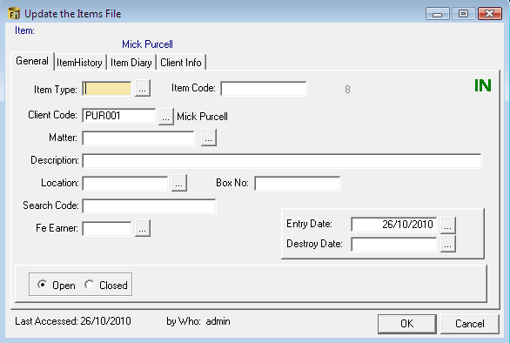***Input*** the following details:

Item Type Click on the  ***... lookup button*** a list of item types will appear. Select the required item type.

Item Code ***Input*** an item code.

Client Code This will default to the current client to amend click on the  ***... lookup button*** and select the required client.

Matter Click on the  ***... lookup button*** a list of cases belonging to the client will appear select the required case

Description ***Input*** a description of the item.

Location Click on the  ***... lookup button*** a list of storage locations will appear select the required location

Box No. ***Input*** the box number if appropriate.

Search Code ***Input*** a search code for the item

Fee Earner Click on the  ***... lookup button*** a list of fee earners will appear select the required fee earner

Entry Date This will default to today’s date amend if required by click on the  
 ***... lookup button*** and selecting the date required.

Destroy Date ***Input*** the destroy date if applicable

Open/Closed This will default to open.

1. Click ***OK***. The item will now appear in the File Manager