Chapter 12: Time Recording

## Time Recording in the Case Diary

Time can be recorded in the case diary in two ways automatically using a timer or manually using a time slip. Once time is recorded it is then posted to the Day Book and from here it is posted to the time ledger of the case. Recorded time can be used for billing, reporting and productivity tracking.

Here are the two tools available in the Case Diary for recording time.

 The Timer

 Manual time slips

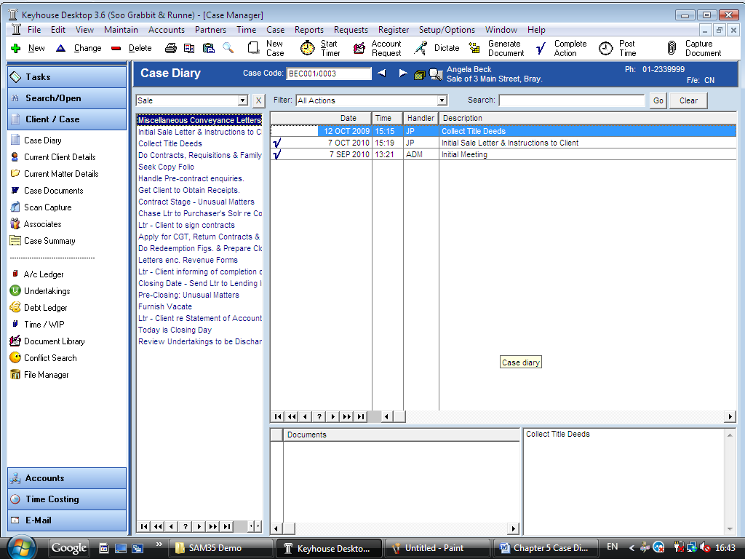

### How to Record Time Using the Timer

The automatic timer launched by clicking on Start Timer  on the case diary toolbar. It allows the user to easily manage and record time for several cases and tasks. It has a clock which can be started and stopped for each task. From here time is updated to the day book ready for posting to the time ledger.

1. ***Open*** a Case in the Case Diary
2. Click ***Start*** ***Timer *** locatedon the ***Case Diary Toolbar***. The following timer will appear displaying the current case reference.
3. Click on the ***clock***  to start the timer the matter code will then appear in yellow.



1. To pause the timer click on the ***clock***. The timer will turn red to denote it has stopped.
2. To ***resume*** click on the ***clock*** the timer will turn yellow and continue accumulating time.

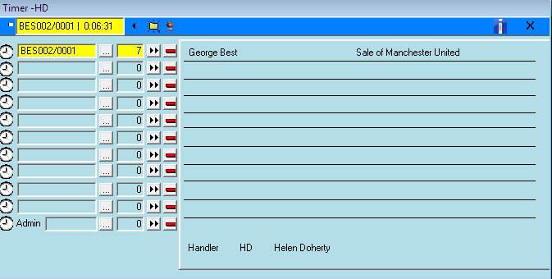

1. When you have finished your timing, click on ***Clock*** to stop the timer.
2. To minimise the window click on ***minimise***.    
     
   To Expand the timer by clicking on ***Maximise***. 
3. You can add in the details and post this time now or later.
4. If you move to another case in the case diary the timer will automatically pause and create a new time recording for the new case and start the clock.
5. 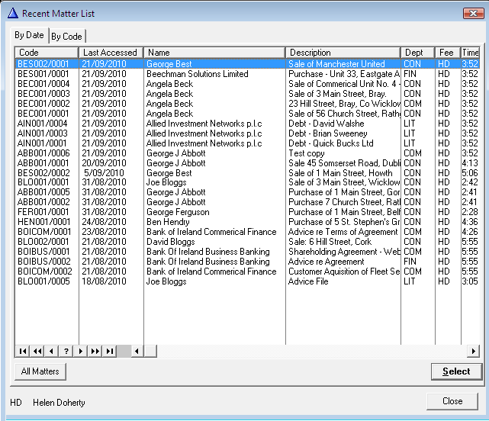Or Alternatively click on the  ***.... lookup button to*** view your Recent Matter list.
6. ***Double click*** the required matter if available.

Or to view a full case list click on ***All Matters***. Search for the required case.

See chapter 2 for further information.

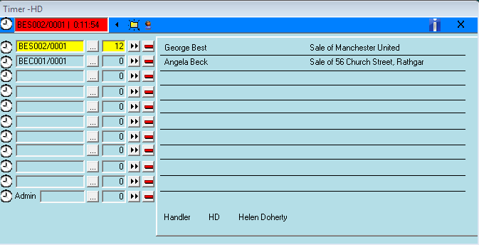

1. The Case reference will appear in the timer, see the following example.



1. Click on the ***Clock*** to the left of the case reference to start the timer.

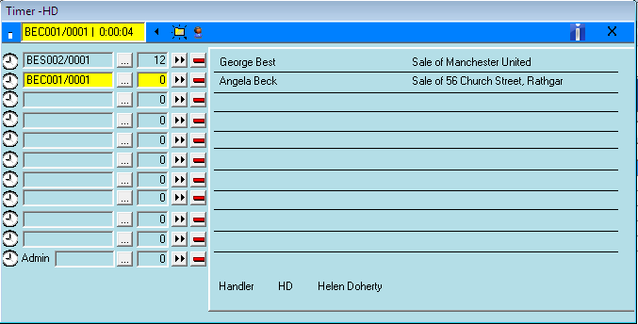

1. The timer that is active appears in yellow. See the following example.
2. Stop the timer as before by clicking on the ***Clock*** and repeat the process for different timer recordings as required.
3. The Recording will remain in the Timer until you post it to the Day Book or to delete it. You can have as many as 10 recording in the Timer for different case matters.

### How to Post Time from the Timer

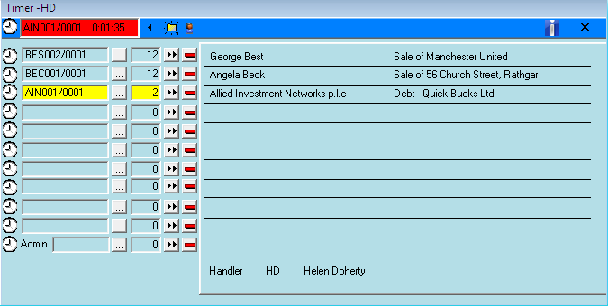

1. ***Maximise*** the Timer screen. The following screen will appear.
2. Next to each time entry is a post time entry button. Click on ***Post time entry***  for the required entry.

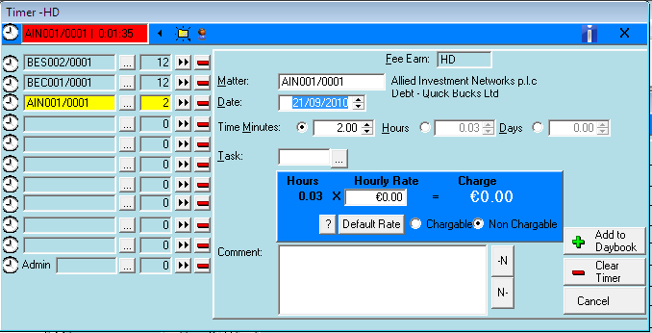

1. The following screen will appear.
2. Input/Amend the following details as required: -

**Matter**: The current case code is automatically inserted

**Date**: Will default to the date the timing was recorded. Amend if required.

**Minutes/Hours/Days:** This will reflect the timings recorded but can be amended if required

**Task**: Click on the ***... lookup button*** to reveal a list of tasks. ***Double Click*** the task required.

***Hourly Rate***: The hourly rate will display the default rate for this handler and case.

**Chargeable/** Using the ***option buttons*** provided select if this is

**Non Chargeable** chargeable or non chargeable time. I.e. time recorded against the case but not charged to the client.

**Comment** Input a narrative to describe the time entry and/or insert a narrative from the narrative list by clicking  to put the narrative before current text or  to put the narrative after the current text.

1. Click on ***Add to Day Book***. This time entry is then transferred to the daybook ready for posting to time ledger.
2. ***Repeat*** this process for each entry.

### How to Record and Post Admin Time Using the Timer

1. ***Open*** a case in the Case Diary
2. Click on ***Start*** ***Timer*** locatedon the ***Case Diary Toolbar***. The timer will appear. Expand the timer by clicking on ***Maximise***.  The following screen will appear.
3. The last line of the timer is used for recording Admin time.
4. Click on the  ***... lookup button*** a list of Admin Tasks will appear. ***Double Click*** the required task.



1. To start the timer click on the ***clock*** to the left of Admin

**Note** Admin Time appears in Red see the following example

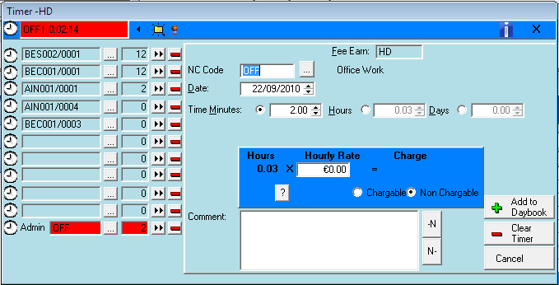

1. To pause the timer click on the ***clock***.

1. To Reactivate click on the clock again.
2. To post click on ***post time entry*** .
3. Input/Amend the following Details

NC Code The admin code for the task selected will appear here to amend click on the  ***... lookup button*** and ***Double Click*** the required code.

Date Today’s date will appear amend if required.

Minutes/Hours/Days: This will reflect the timings recorded but amended if required.

Chargeable This will default to Non-Chargeable for Admin Time.

Comment ***Input*** a narrative to describe the time entry and/or insert a narrative from the narrative list. 

1. Click on ***Add to Day Book***. This time entry is then transferred to the daybook ready for posting to time ledger.

### How to create a Time slip

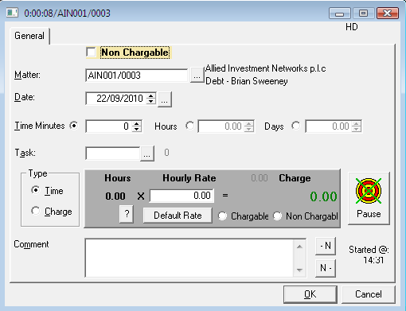

1. ***Open*** a Case in the Case Diary
2. Click on ***Post time***  locatedon the ***Case Diary Toolbar*** to open a Time slip.
3. ***Input*** or Amend the following details

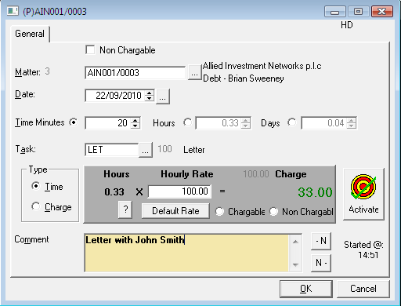Matter The current case code will appear to amend click on the  ***... lookup button*** and ***double click*** the required case.

Date By default today’s date will appear this can be amended if required by clicking on the  ***... lookup button*** then ***Double Click*** the date required.

Time Select minutes/hours or days. ***Input*** the amounts in the boxes provided. If you are using the timer this will automatically appear but you can input manually.

Task: Click on the  ***... lookup button*** to reveal a list of tasks. Double click the task required.

Type Time Using the option buttons provided ***select*** either ***Time*** or ***Charge***. Time will calculate based on an hourly rate for the current handler. Charge will disregard the time recorded and apply a set charge for the current task selected.

Hourly Rate: The hourly rate will display the default rate for this handler and case.

Chargeable Using the ***option buttons*** provided ***select*** if this is ***chargeable or non chargeable time***.

Comment ***Input*** a narrative to describe the time entry and/or insert a narrative from the narrative list by clicking on the ***insert narrative*** button.

1. When all details have been entered click ***OK***. The time slip will appear in the Daybook ready for posting.

### How create a Admin Time slip

1. ***Open*** the ***Case Diary.***

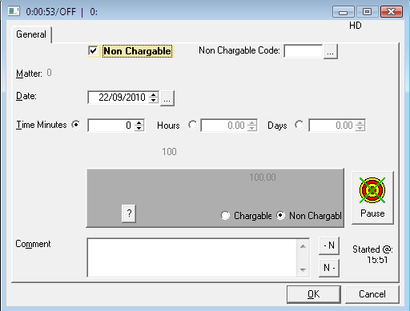

1. Click on ***Post time***  locatedon the ***Case Diary Toolbar***. The following Time slip will appear.
2. Put the ***tick*** in ***Non Chargeable*** the following screen will appear
3. Input/Amend the following Details

NC Code Click on the ***... lookup button*** a list of Non-chargeable codes will appear and double click the required code

Date Today’s date will appear amend if required.

Minutes/Hours/Days: This will reflect the timings recorded but amended if required

Chargeable This will default to ***Non-Chargeable*** for Admin Time

Comment ***Input*** a narrative to describe the time entry and/or insert a narrative from the narrative list by clicking on the insert narrative buttons.

1. Click on ***Add to Day Book***. This time entry is then transferred to the daybook ready for posting to time ledger.

## My Day Book

### Viewing My Day Book

1. Click on ***Time Costing*** on the Shortcut Bar the day book will appear listing all your unposted time.

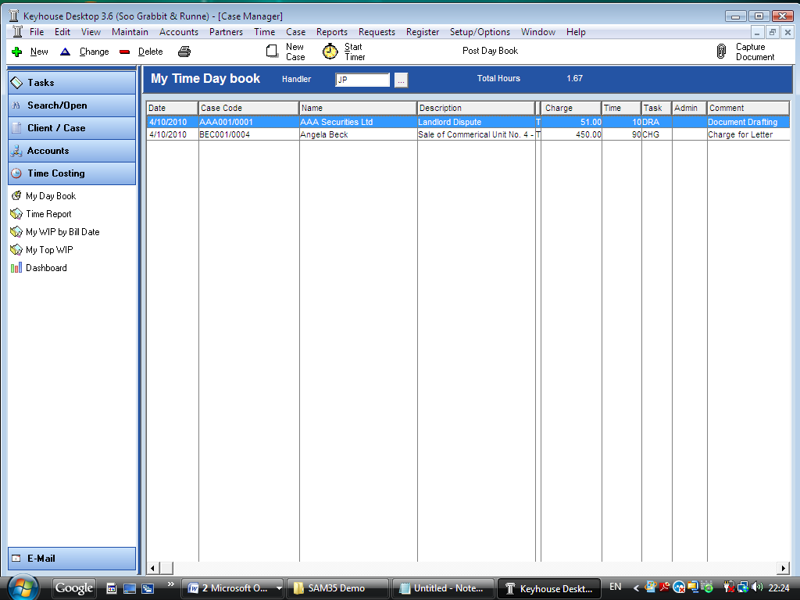

1. Click on the ***menu*** item required.

### How create a Time slip

1. Click on ***New***  locatedon the ***Day Book toolbar***. The following Time slip will appear.
2. ***Input*** the details such as date, time, task etc. For further information see the section on ***How to create a Time Slip in the Case Diary.***
3. When all details have been entered click ***OK***. The time slip will appear in the Daybook ready for posting.

### How to create a Admin Time slip

1. Click on ***New***  locatedon the ***Day Book toolbar*** a Time slip will appear.
2. Put the ***tick*** in Non Chargeable the following screen will appear.
3. ***Input***/***Amend*** the details as described in the section How to create a Admin Time Slip in the Case Diary.
4. Click on ***Add to Day Book***. This time entry is then transferred to the daybook ready for posting to time ledger.

### How to amend a Time Slip

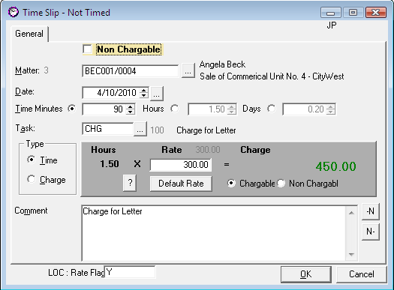

1. Go to the ***Daybook***
2. ***Double click*** on the required time slip or click on change . The following dialogue box will appear.
3. ***Amend*** as required.
4. Click ***OK.***

### How to Delete a Time Slip

1. Go to ***Daybook***
2. Click on the time slip you want to ***delete***.
3. Click on ***Delete***  a message will appear asking you to confirm.
4. Click ***OK***.

### How to Post the Day Book

1. Go to the ***Daybook***
2. Click on ***Post Day Book***  located on Daybook toolbar this will post each time recording to the time ledger of each matter.

### View the Time Ledger

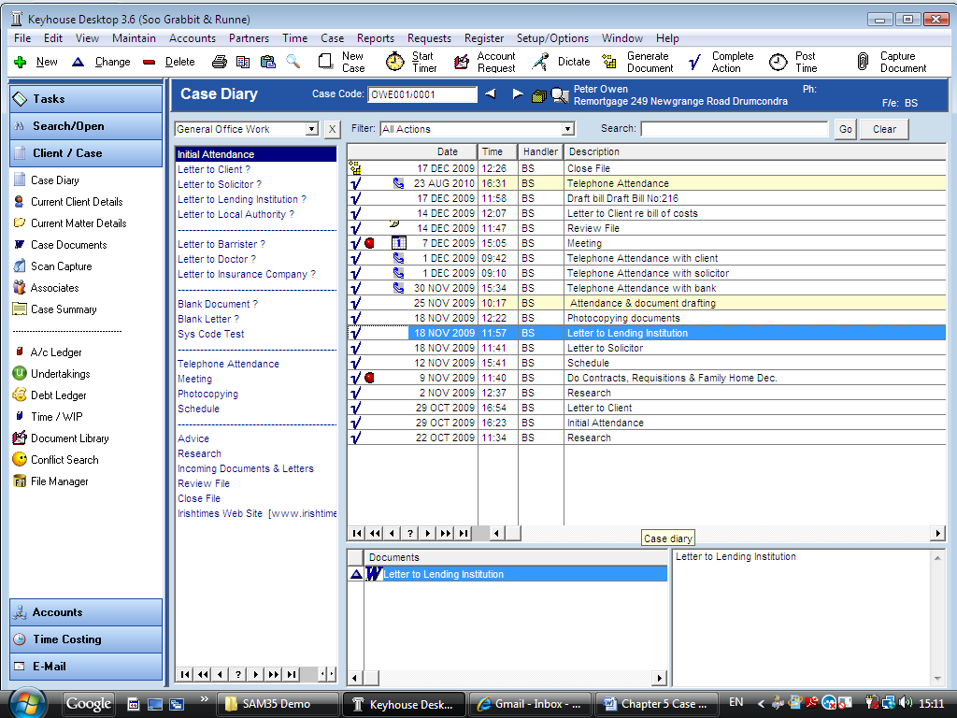

1. ***Open*** a case in the Case Diary.
2. Click on ***Time/WIP*** on the ***Case Diary Shortcut Bar***.
3. 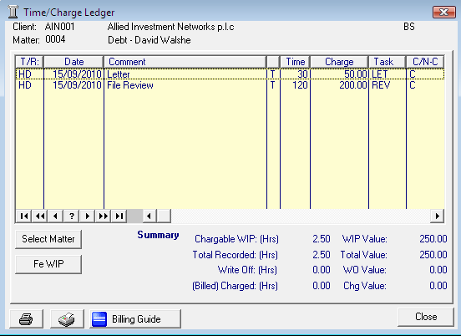The following dialogue box will appear displaying the Time Ledger.

## Time Reports

To Report from the day book click on the options on the menu on the left.

### The Time Report

1. Click on ***Time Costing*** on the Shortcut Bar the following menu will appear
2. 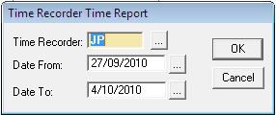Click on ***Time Report*** the following dialogue box will appear.

***Input*** the following details

Time Recorder The time recorder will default to the logged on User to amend click on the  ***… lookup button*** a list of time recorders will appear Double click the required time recorder.

Date From Click on the  ***… lookup button*** a calendar will appear. Double click the start date of the report.

Date To Click on the  ***… lookup button*** a calendar will appear. Double click the end date of the report.

1. Click ***OK***. The report will run see the following example.

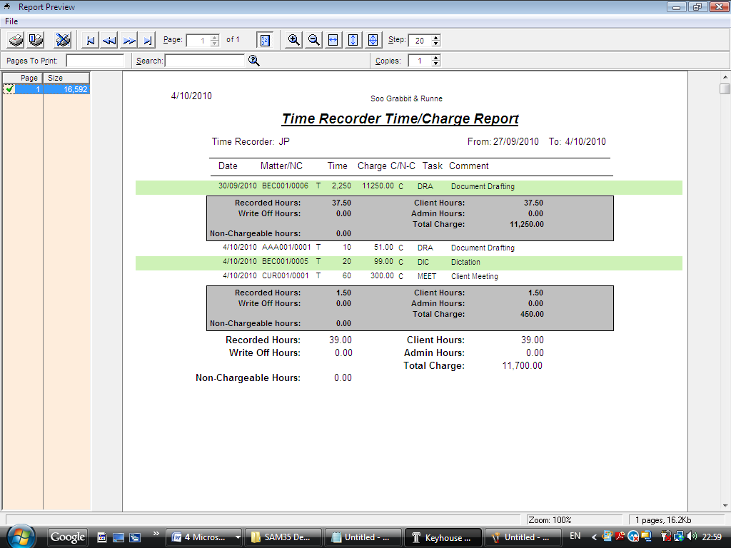

### My WIP by Bill Date

1. Click on ***Time Costing*** on the Shortcut Bar the following menu will appear.
2. Click on ***My WIP by Bill Date*** the report will run.

WIP is work in progress i.e. unbilled time

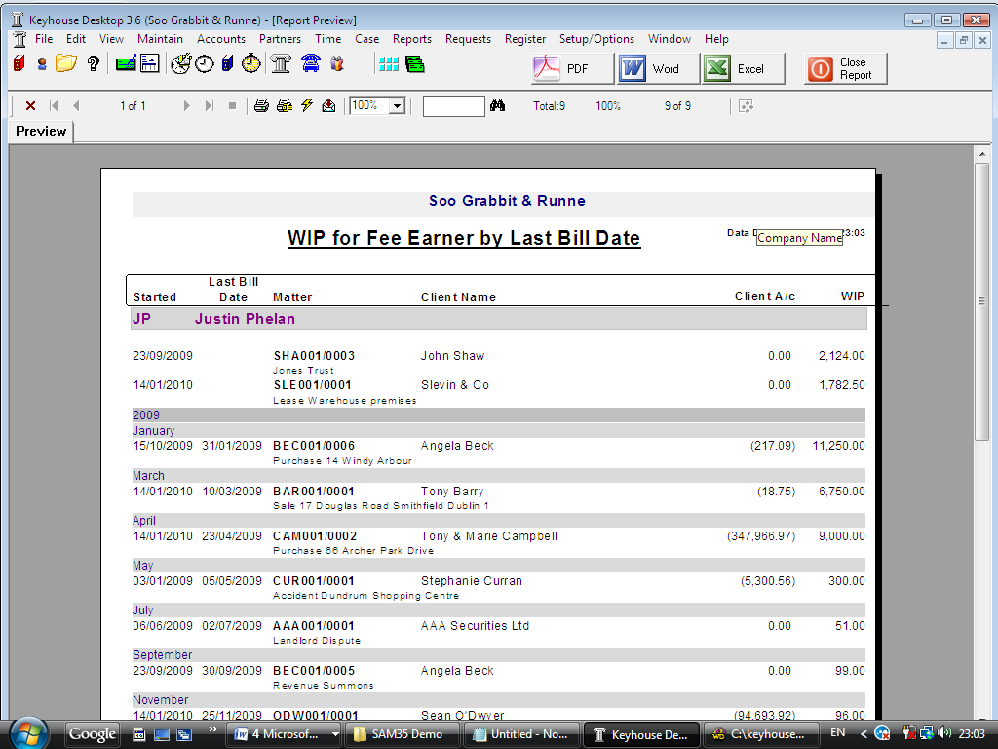

1. Once the Report has run the following options are available



Close Report Click ***Close*** Report to Close the Report.

PDF Click ***PDF*** to export to Adobe Acrobat.

Word Click ***Word*** to export to Microsoft Word.

Excel Click ***Excel*** to Report to Report.

Print Click ***Print***  on the report toolbar.

### My Top WIP



1. Click on ***Time Costing*** on the Shortcut Bar the following menu will appear
2. Click on ***My Top WIP Date*** the report will run. See the following example.

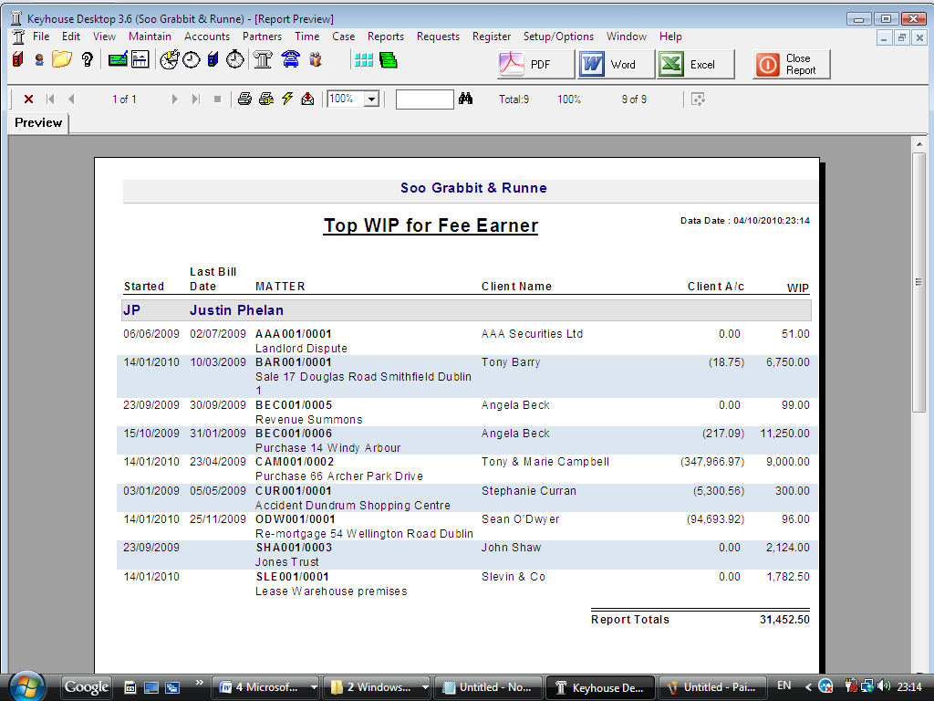

1. Once the Report has run the options to export to PDF, Word etc. or to Print or Close are available. See the section on the My WIP by Bill Date Report for further details.

### KPI Reports



1. Click on ***Time Costing*** on the Shortcut Bar the following menu will appear
2. Click on ***Dashboard*** the report will run. See the following example

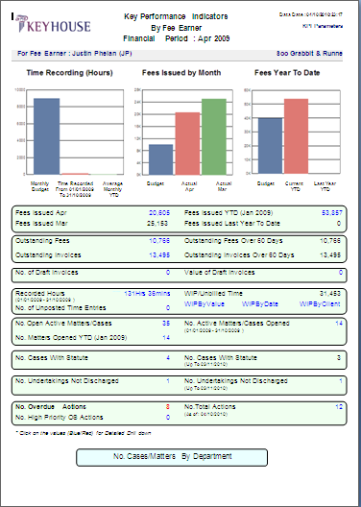

1. Click on the figures in ***blue*** or ***red*** to run a sub report with a breakdown of the details that made up that figure. See the following example of a “Breakdown of fees issued for April 2009”

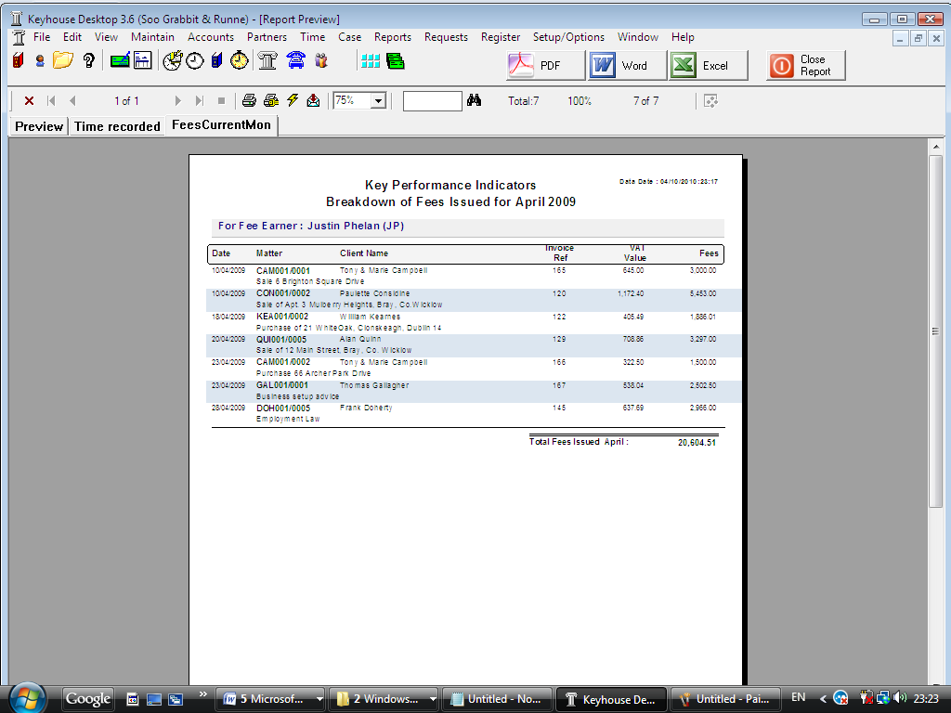

1. Click on the ***Preview*** tab to return to the main KPI report.
2. Once the Report has run the options to export to PDF, Word etc. or to Print or Close are available. See the section on the ***My WIP by Bill Date Report*** for further details.