Chapter 13: Accounts

## Account Functions in the Case Diary

### View the Matter Ledger

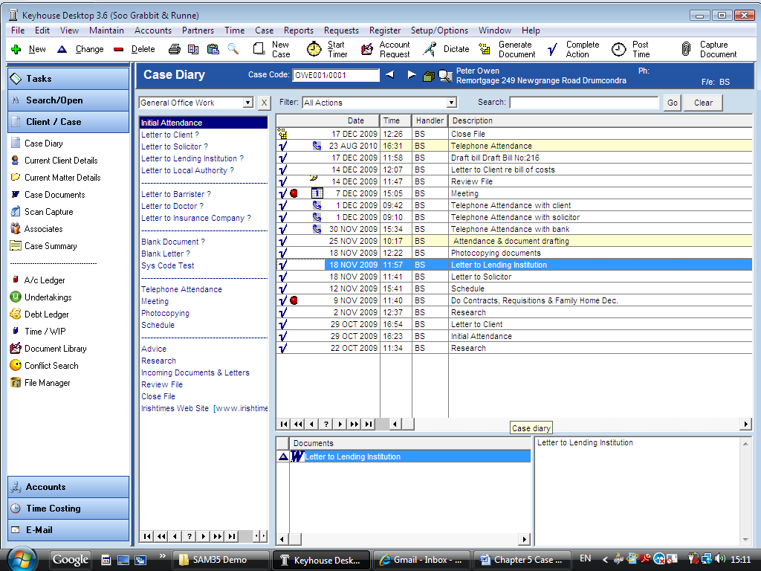

1. ***Open*** a case in the Case Diary.
2. Click on ***A/C Ledger*** on the Case Diary Shortcut Bar.
3. 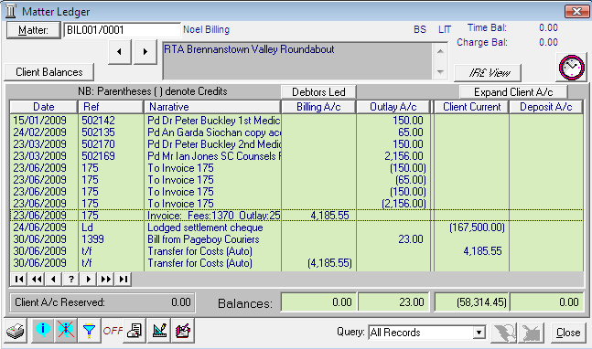The following dialogue box will appear.

**Note**: For further information on the matter ledger see the SAM Accounts Manual.

### How to Create a Cheque Request

1. ***Open*** a case in the Case Diary.
2. 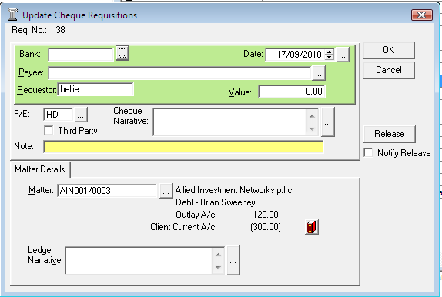Click on ***Account Request*** on the ***Case Diary Toolbar***. The following menu will appear.
3. Click on ***Request Cheque***. Input the following information:

Bank Click on the ***...lookup button*** a list of bank accounts will appear, ***double click*** the bank account required.

Date The date will default to today’s date to amend click on the  ***... lookup button*** a calendar will appear ***double click*** the required date.

Payee Input the Payee’s Name or to select from the supplier list, click on the  ***… lookup button***, ***double click*** on the supplier required.

Requestor This will default to the current user.

Value ***Input*** the amount of the cheque.

F/E This will default to the current Fee Earner to amend click on the  ***... lookup button*** a list of Fee Earners will appear, ***double click*** on the Fee Earner required.

3rd Party ***Tick*** if this is a 3rd Party cheque

Cheque ***Input*** a cheque narrative or click on the ***... lookup button*** to pick from

Narrative a list of narratives, ***double click*** the narrative applicable.

Note ***Input*** a note to the accounts department if required.

Notify ***Tick*** if you want to email the accounts department.

Release

Matter This will default to the current case open in the case diary to amend click on the  ***... lookup button*** a list of cases will appear ***double click*** the required case.

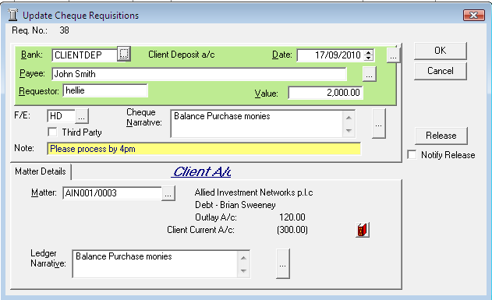Ledger This will default to the cheque narrative but it can be amended by

Narrative clicking in the input box provided and amending. Alternatively click on the  ***... lookup button*** for a list of ledger narratives ***double click*** the narrative applicable.

See the following example

1. To release the cheque to account click ***Release***. Alternatively to hold the cheque in your cheque list click OK.

### How to Create a Draft Bill

1. ***Open*** a case in the Case Diary.



1. Click on ***Account Request*** on the ***Case Diary Toolbar***.
2. 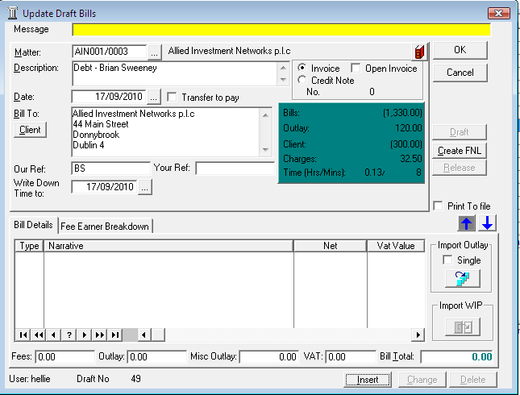Click on ***Draft Bill.*** The following dialogue box will appear.

Input the following information

Message ***Input*** a message for the account department (optional)

Matter This will default to the current case open in the case diary to amend click on the  ***... lookup button*** and search for the required case.

Description This will default to the matter description to amend click in the input box provided and amend.

Invoice/ This will default to Invoice click on ***Credit Note*** to create a Credit Note.

Credit Note

Open Invoice To create an open invoice put a tick in ***Open Invoice***.

Date The date will default to today’s date. To amend click on the  
 ***... lookup button*** a calendar will appear double click the required date.

Transfer to Pay ***Tick*** this to transfer funds from the client account to pay the bill.

Bill to This will default to the client details. To amend click in the input box provided and ***type*** the Name and Address of the person or company receiving the invoice. Click on the  ***Client button*** to revert to the client details.

Our Ref This will default to the Fee Earners initials, click in the ***input box*** provided and ***amend*** if required.

Your Ref Click in the input box provided and ***input*** a reference

Write down time to The date will default to today’s date to amend click on the   
 ***… lookup button*** select the required write down date.

Print to file ***Tick*** if you want to Print to a file

1. Insert the Bill Details this can be done by importing time recorded on the case, by importing outlays or by manually inputting fees and outlays.

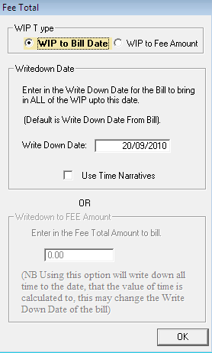

See the following options

* 1. Importing Time Recorded

Click on ***Import WIP***  ***two*** ***options*** are available.

1. Select ***WIP to Bill Date*** to include all time recorded on the case to a specific date. If you select this option.

The Write Down Date appears input the date.

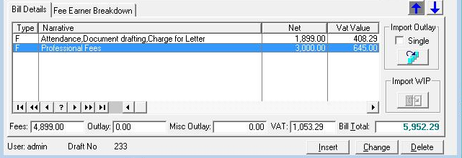Put the ***tick*** in Use Time Narratives to use the time narratives on the bill

1. 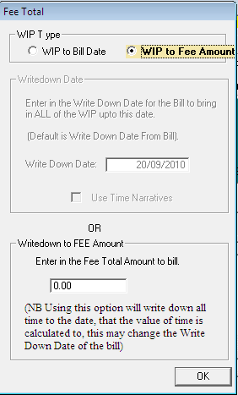Select ***WIP to Fee Amount*** to write down time on the case to the write down date and to a specific value. The following options will appear



1. ***Input*** the fee amount to bill and click ***OK***.

* 1. Import Outlays

1. 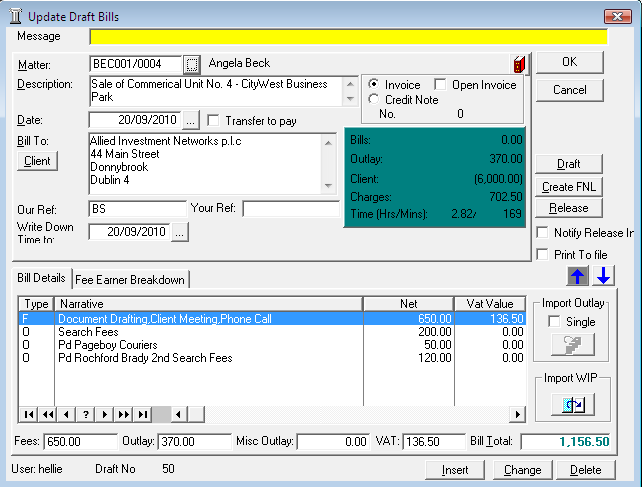Click on ***Import Outlay*** 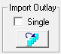 to import all outlays individually from the matter ledger.
2. To import outlays as a single line in the bill put the ***tick*** in ***Single***.
   1. Inputting Fees Manually
3. 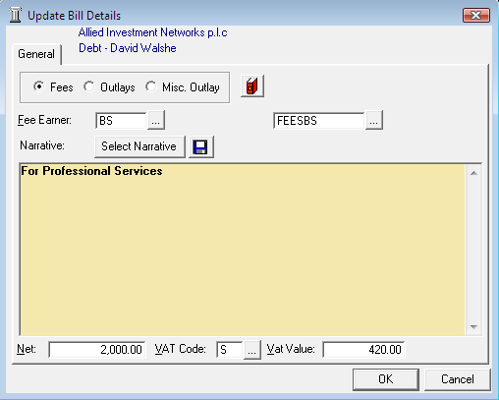Click ***Insert***. The following dialogue box will appear. ***Select*** the option Fees.
4. ***Input*** the following information

Fee Earner The Fee Earner will default to the current fee earner to change click on the ***... lookup*** and ***double click*** the required fee earner.

Nominal A/C The nominal account will default to that of the fee earner selected. To amend click on the   
 ***... lookup button*** and ***double click*** the required account.

Narrative ***Type*** a narrative in the input box provided. Alternatively click on the narrative button to display a list of narratives ***Select*** the required narrative.

Net ***Input*** the net fee amount

VAT The Code will default to the system VAT code amend if required.

VAT Value This amount is calculated automatically based on the net amount and the vat code selected above.

* 1. Inputting Outlays Manually

1. Click on ***Insert*** and ***Select*** the option ***Outlays*** or ***Misc. Outlays***.
2. 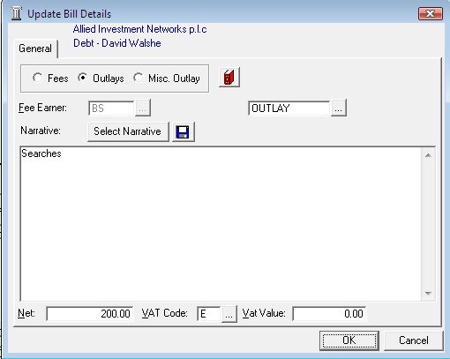***Input*** the following information

Nominal A/C The nominal account will default to Outlay to change click on the ***... lookup button*** and ***double click*** the required account.

Narrative ***Input*** a narrative in the input box provided. Alternatively click on the narrative button to display a list of narratives, ***double click*** on the required narrative.

Net ***Input*** the net outlay amount.

VAT This will default to VAT Code E i.e. 0% if outlay is selected. To amend click on the  ***... lookup button*** a list of VAT Codes will be displayed ***double click*** on the required VAT code.

VAT Value This amount is calculated automatically based on the net amount and the vat code selected above.

1. 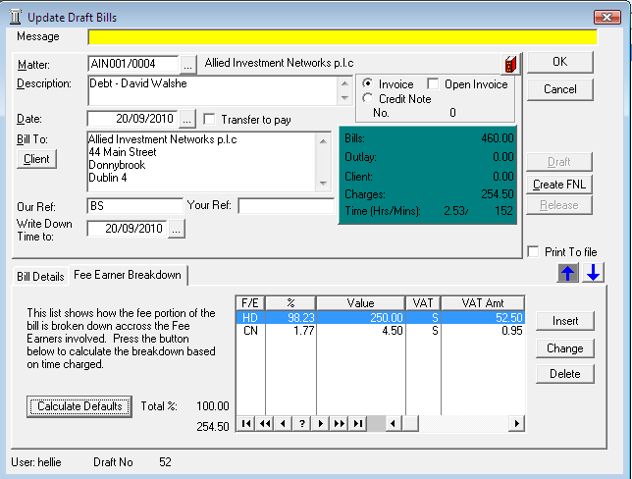Fee Earner Breakdown
   1. Calculate Breakdown based on Time Charged
2. ***Click*** on ***Calculate Defaults***
3. The system will calculate the fee breakdown automatically based on time charged. To amend use ***Change***  or ***Delete***  buttons.
   1. 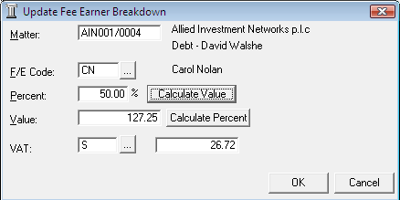Insert Fee Earner Breakdown Manually
4. Click on ***Insert***. The following dialogue box will appear.
5. Input the following details:

F/E Code Click on the  ***...lookup button*** and ***Select*** the required fee earner from the list.

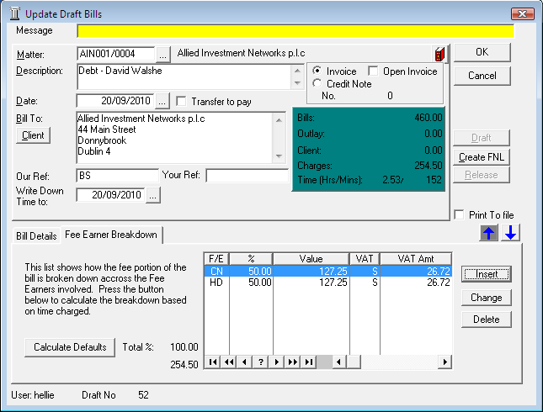Percent ***Input*** the Percentage amount of fees this fee earner has earned. ***Click*** ***Calculate Value*** to calculate the value.

***OR***

Value ***Input*** the Amount of fees this fee earner has earner. Click ***Calculate Percent*** the percent to calculate in the Percent box above.

1. Click ***OK***.
2. Click ***OK*** to save the draft bill.
3. The Draft Bill will appear as an entry in the case diary for future review.



1. To release ***Open*** the Draft Bill and click on the ***Release button***.

## The Accounts Menu

### Accessing the Accounts Menu

1. 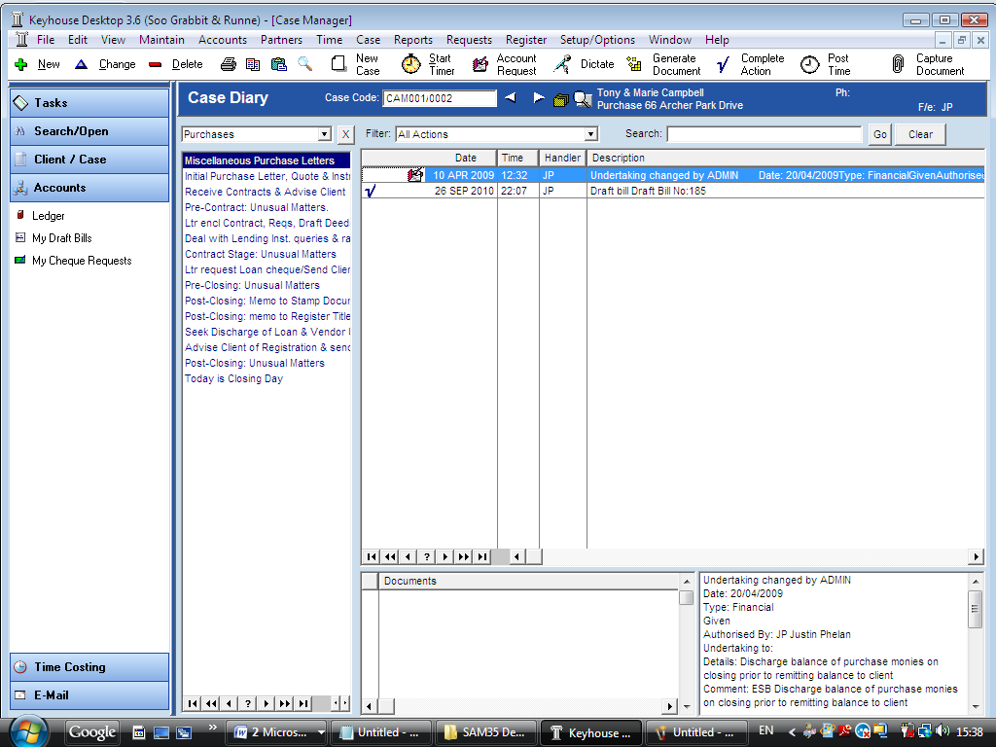***Open*** a Case in the Case Diary.
2. Click on ***Accounts*** on the Shortcut Bar the following options will appear.
3. Click on the ***Ledger to view the ledger.***
4. Click on ***My Draft Bills*** to view your draft bills or ***Cheque Requests*** as required.

### Viewing the Case/Matter Ledger

1. ***Open*** a Case in the Case Diary.
2. Click on ***Accounts***.
3. Click on ***Ledger*** the Matter Ledger will appear.
4. To view the ledger of another case click on the ***Matter Button*** located at the top of the screen. A full list of matters will appear ***Search*** for the required case in the normal way. (See chapter 3 for further information.)
5. Then ***Double click*** the required matter.
6. The matter ledger will then appear for the selected matter.

***\* For further information on the matter ledger see the SAM Accounts Manual.***

## My Draft Bills

### How to View My Draft Bills



1. Click on ***Accounts*** on the Shortcut Bar.
2. Click on ***My Draft Bills*** a screen will appear displaying a list of your draft bills.

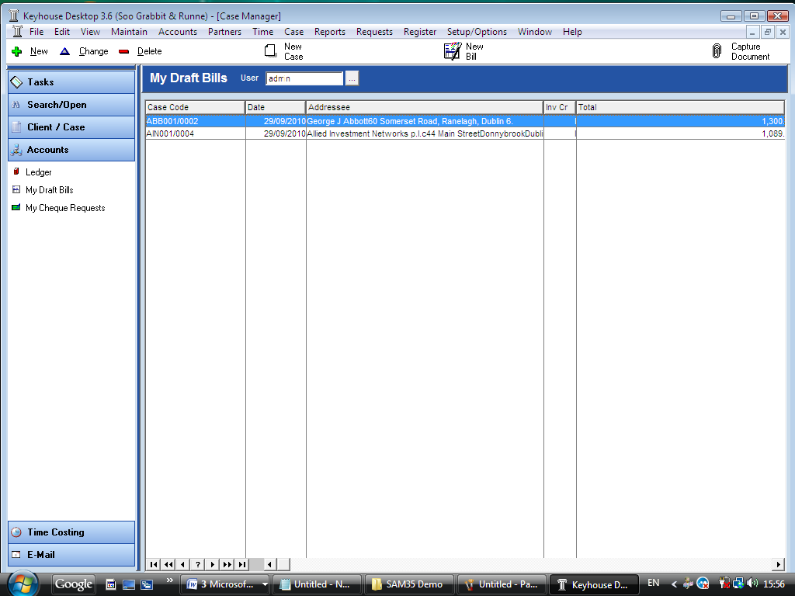

### How to Create a Draft Bill



1. Go to ***My Draft Bills***.
2. Click on ***New Bill*** located on the ***My Drafts toolbar*** a new draft bill will appear.
3. Complete as outlined in the previous section in this chapter on ***Creating a Draft Bill in the Case Diary***.

### How to Amend a Draft Bill

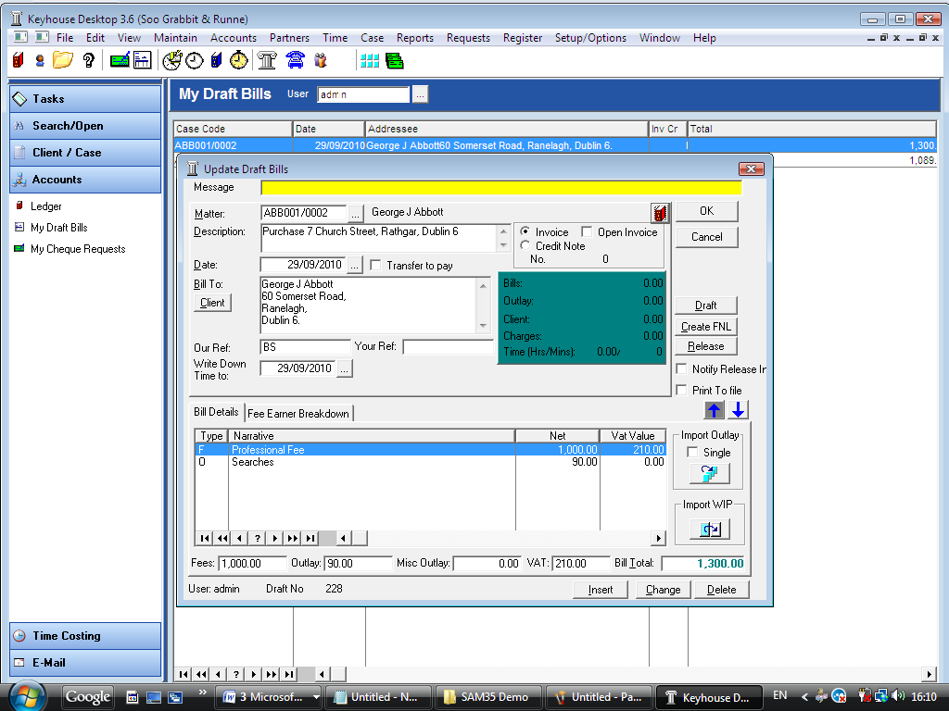

1. Go to ***My Draft Bills*** a screen will appear displaying a list of your draft bills.
2. ***Double click*** on the bill to be amended the draft bill will appear.
3. ***Amend*** as required.
4. Click ***OK*** to save the changes or click ***Release*** to save the change and send to Accounts for approval.

### How to Delete a Draft Bill

1. Go to ***My Draft Bills.***
2. Click on the bill you want to delete.
3. Click on ***Delete***  located on the ***My Drafts toolbar*** or press ***delete*** on your keyboard a message will appear asking you to confirm the deletion.
4. Click ***OK*** to delete.

### How to Release a Draft Bill to Accounts

1. Go to ***My Draft Bills***.
2. ***Double click*** on the bill to be released, the draft bill will appear.
3. Click on the ***Release*** button  to send to Accounts for approval.

### How to Print a Draft Bill



1. Go to ***My Draft Bills***.
2. ***Double click*** on the bill you want to Print the draft bill will appear.
3. Click on the ***Draft*** button  a draft bill will appear.
4. Click on ***Print*** located on the report toolbar to print the draft bill.

## My Cheques

### Viewing My Cheques



1. Click on ***Accounts*** on the Shortcut Bar the following options will appear.
2. 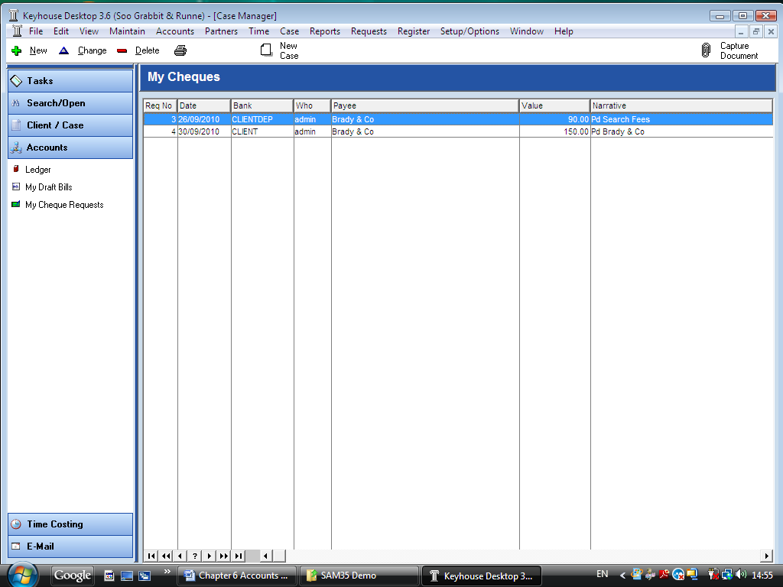 Click on ***My Cheque Requests*** a screen will appear displaying a list of your cheque requests.

### How to Create a Cheque Request

1. Go to ***My Cheque Requests***.
2. Click on ***New Cheque***  located on the ***My Cheques Toolbar*** a new cheque requisition will appear.
3. Complete as outlined in the previous section in this ***Chapter on Creating a Cheque Request in the Case Diary***.

### How to Amend a Cheque Request

1. Go to ***My Cheque Requests*** a screen will appear displaying a list of your cheque requests.

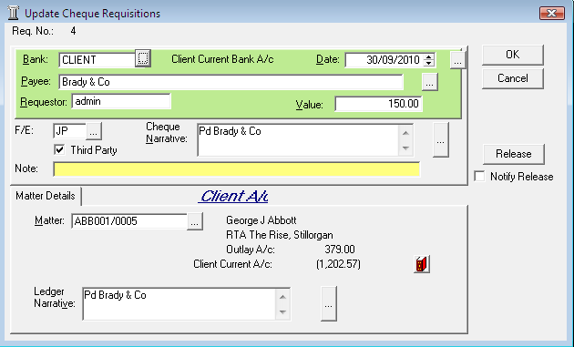

1. To select ***Double Click*** on the cheque you want to amend the cheque request will appear.
2. ***Amend*** as required.
3. Click ***OK*** to save the changes or click ***Release*** to save the changes and send to Accounts.

### How to Delete a Cheque Request

1. Go to ***My Cheque Requests a*** screen will appear displaying a list of your cheque requests.
2. To select ***click*** on the cheque you want to delete
3. Click on ***Delete*** located on the ***My Cheques Toolbar*** a message will appear asking you to confirm the deletion.
4. Click ***OK***

### How to Release a Cheque Request

1. Go to ***My Cheque Requests*** a screen will appear displaying a list of your cheque requests.



1. To select ***double*** ***click*** on the cheque you want to release to accounts the cheque request will appear.
2. Click ***Release***. The cheque will know be sent to Accounts for approval.

### Print a list of My Cheques

1. Go to ***My Cheque Requests***.
2. 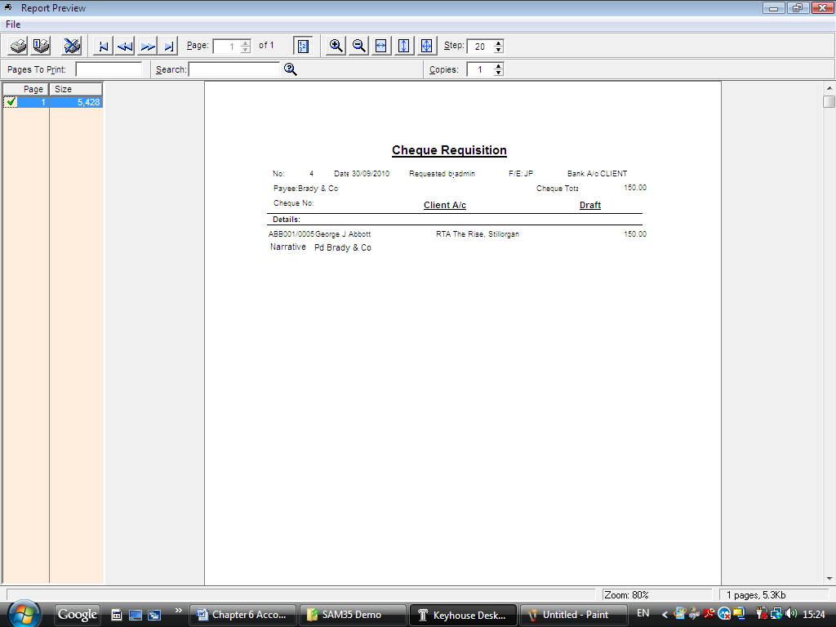Click on ***Print*** located on the ***My Cheques Toolbar*** a report will appear.
3. To ***Print***  click on ***Print*** located on the Report toolbar.