Chapter 14: The Debt Ledger

## How to add Original Debt

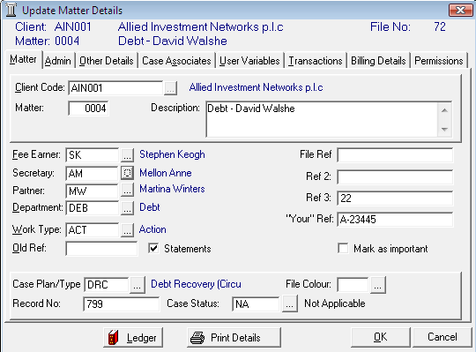

1. ***Open*** a case in the ***Case Diary***.
2. Click on ***Current Matter Details***  located on the ***Case diary*** shortcut bar.
3. The ***Update Matter details*** screen will appear.
4. 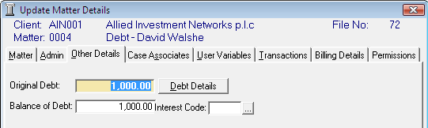Click on the ***Other Details*** Tab (circled in red) an Original Debt input box will appear.
5. ***Input*** the original debt amount and using the  ***… lookup button*** select the interest code, if applicable.

**Note** the balance of debt will update automatically as postings are made.

## How to View the Debt Ledger

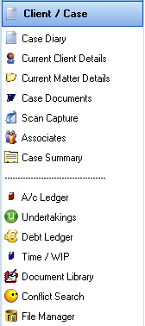

1. ***Open*** a case in the Case Diary.
2. Click on ***Debt Ledger*** on the ***Case Diary Shortcut Bar***.
3. 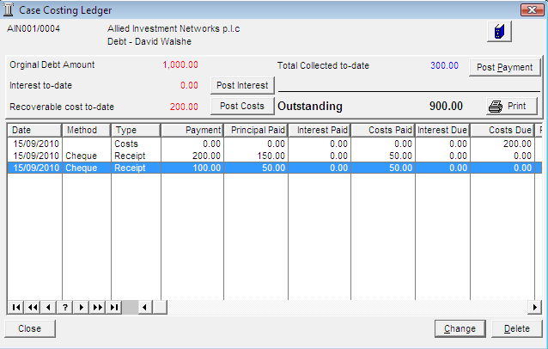The ***Case Costing Ledger*** will appear.

## How to Post a Payment

1. Click on ***Post Payment*** the following dialogue box will appear.

Input the following information:

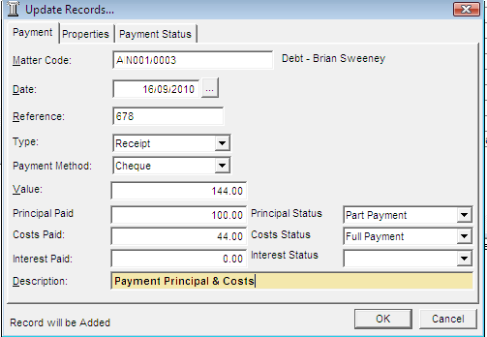

Date The date will default to today’s date amend if required.

Reference ***Input*** a reference.

Type Click on the ***down* *arrow*** and select the ***payment*** ***type*** applicable.

Payment Method Click on the ***down arrow*** and ***select*** the ***payment method*** applicable.

Value ***Input*** the value of the payment.

Principal Paid ***Input*** the amount of the principal paid.

Principal Status Click on the ***down arrow*** and ***select*** the principal status applicable.

Costs Paid ***Input*** the amount of costs paid.

Costs Status Click on the ***down arrow*** and ***select*** the ***cost status*** applicable.

Interest Paid ***Input*** the amount of interest paid.

Description ***Input*** a description for this payment.

1. Click ***OK*** to post the payment. The debt balance will update.

## How to Post Costs

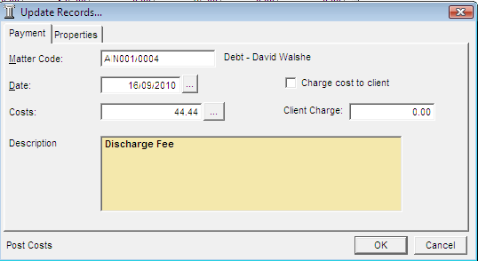

1. Click on ***Post Costs*** a posting screen will appear.
2. Input the following information

Date The date will default to today’s date amend if required.

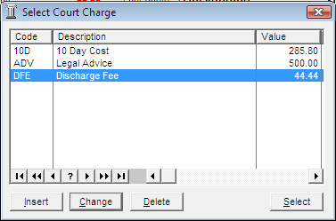Costs Input a cost or click on the  ***… lookup button*** a list of court charges will appear click on the required cost.

Description ***Input*** a description of the cost.

Charge Cost ***Tick*** if the cost is

to client chargeable to the client and the debtor.

Client Charge ***Input*** the value of the cost chargeable to the client.

1. Click ***OK*** to post the cost, the balance will update.

## How to Post Interest

1. Click on ***Post Interest*** a post interest dialogue box will appear.

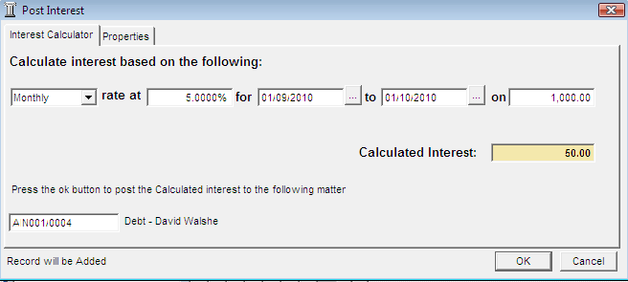

Input the following information:

Term Click on the ***down arrow*** and ***select*** the term i.e. Monthly, Yearly etc.

Rate at ***Input*** the rate of interest

For Click on the  ***… lookup button*** a calendar will appear select the start date and end date.

On ***Input*** the amount the interest is to be calculated on.

**Note** Once the information is provided the interest will calculate automatically and will then be displayed in the Calculated Interest box.

1. Click ***OK*** to post the interest and the balance will automatically update.

## How to Amend a Entry

1. 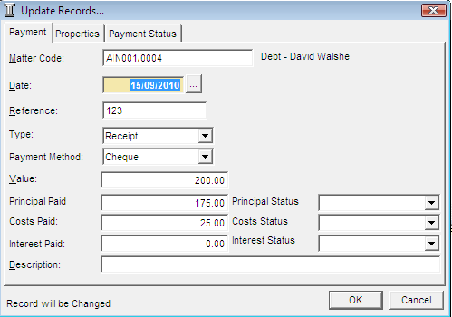Open the ***Debt Ledger***
2. Click on the entry you want to amend.
3. Click on ***Change*** the following dialogue box will appear.
4. Amend as required and click ***OK*** to post the change.

## How to Print a Debt Ledger Report

1. ***Open the Debt Ledger.***
2. Click on ***Print*** a report will be generated see the following example.

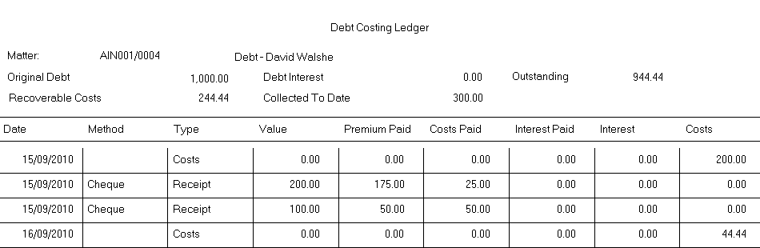

1. Click on ***Print***  on the Report Toolbar.