Chapter 15: Phone Log

## Viewing the Phone Log

1. Click on ***Case*** on the Menu Bar.

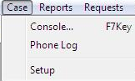

1. A menu will appear click on ***Phone log.***
2. The ***Phone Log*** will open displaying all recorded calls.

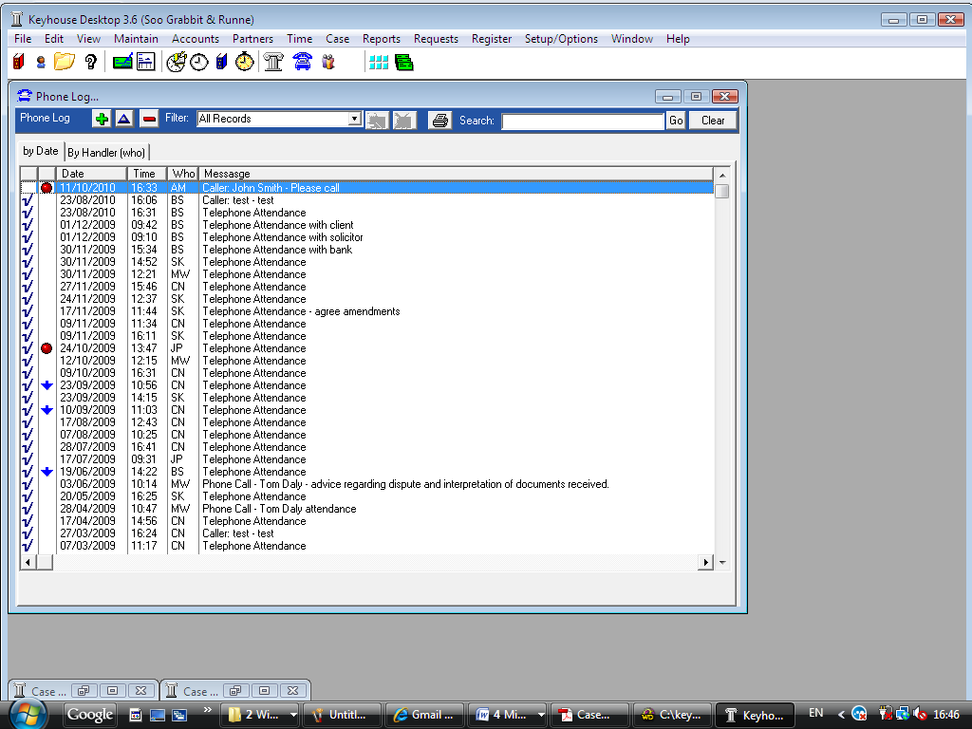

## How to add a phone message

1. 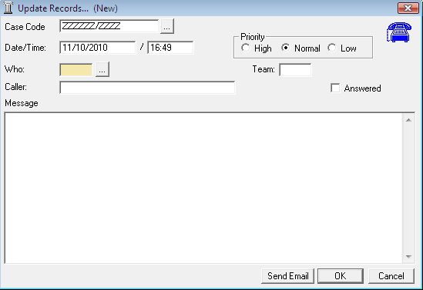***Open*** the phone log.
2. Click on ***Add***  the following dialogue box will appear.

***Input*** the following detail

Case Code This will default to ZZZZZZ/ZZZZ this is used for messages that are not connected with a case. To select a case click on the  ***… lookup*** ***button*** and search for the required case.

Date/Time This is the current date and time of the message.

Priority Using the option buttons provided, ***select*** the priority of the message.

Who Who is the message for. Click on the ***…lookup button*** a list of handlers will appear ***Select*** who the message is for.

Caller ***Input*** the caller’s name.

Message ***Input*** the message.

Answered ***Tick*** this only when the message has been answered otherwise the message will not appear in the handlers to do list.

1. Click ***OK*** the message will then appear in the selected handlers to do list.
2. To send an email click ***Send Email***.

## How to amend a phone message

1. 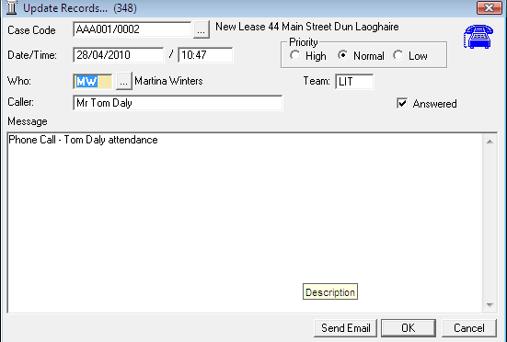In the phone log select the message you want to amend
2. Click on ***Amend button***  the following dialogue box will appear.
3. Amend as required.
4. Click ***OK*** to save the changes.

## How to delete a phone message

1. ***Open*** the phone log.
2. ***Click*** on the message you want to delete.
3. Click on ***Delete*** ***button***  a message will appear asking you to confirm the deletion.
4. Click ***OK.***

**Note**: If you delete a message it will be removed from the system completely.

## How to search for a message



1. ***Open*** the phone log
2. ***Click*** in the Search box provided, located on the phone log toolbar.
3. ***Input*** the keyword and click ***Go***.
4. A list of phone messages matching the criteria will be returned in the list below.
5. Click ***Clear*** to return all messages.

## How to filter phone messages

1. ***Open*** the phone log
2. Click on ***drop down arrow*** to reveal the filter list.
3. Select the required filter e.g. Today’s messages, a list of messages matching the filter selected will be displayed in the screen below.
4. To clear the filter, select ***All records*** from the filter list.

## How to view a specific handler’s messages

1. 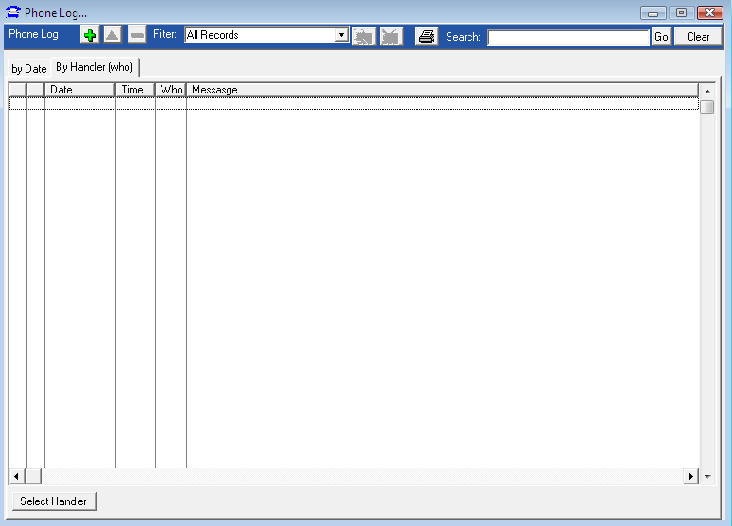***Open*** the phone log
2. Click on the ***handler tab***. The following screen will appear.
3. Click on ***Select handler***, a list of handlers will be displayed. Select the required handler.
4. A list of messages assigned to that handler will appear.

## How to print a list of phone messages

1. ***Open*** the phone log
2. Click on the ***Print*** tool  located on the ***phone log toolbar***.
3. A message will appear asking “Would you like to apply a query to this report?”
4. 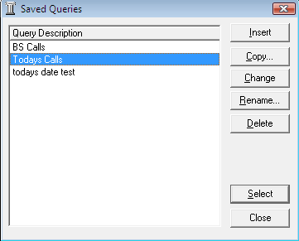If you want to apply a query click ***Yes***. A list of queries will be displayed, select the required query and click ***Select***.
5. If you do not want to apply a query click ***No*** and a full list of all messages in the phone log will be created.
6. To print click on the ***Print*** tool located on the ***Report toolbar.***