Chapter 16: Archiving and Moving Matters/Cases

## View Archived Matters

**Note** You can also search and view archived matters in the Advanced Search. See Chapter 3 for further details.

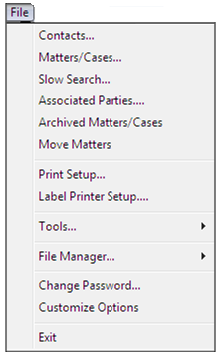

1. Click on ***File*** on the menu bar a menu will appear.
2. Click on ***Archived Matters/Cases***. The following dialogue box will appear.

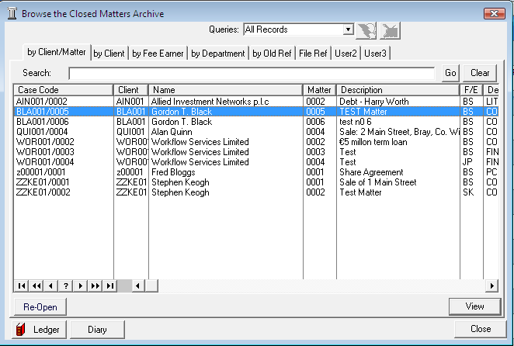

1. Click in the ***Search box*** provided. Input a key search word.

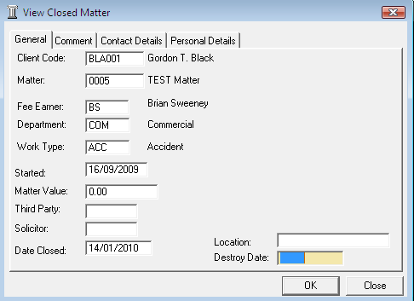

1. Click ***Go***.
2. ***Select*** the required matter.
3. Click the ***View Button*** to view the closed matter details. See the following example.
4. Click the ***close*** ***button*** to cancel or click ***OK*** to save any changes you may have made.

## View Archived Matter Ledger

1. Open the ***Archived Matter Screen*** and ***Search*** for the required archived matter.
2. ***Select*** the required matter.
3. 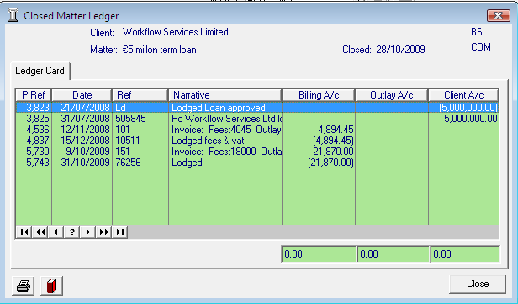Click on the ***Ledger button***. The closed matter ledger will appear for the selected matter. See the following example.
4. Click the ***Close*** ***button*** when complete.

## View Archived Diary

1. 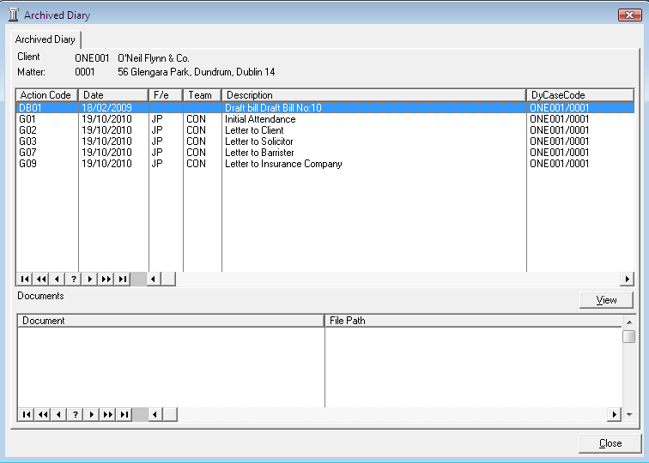Open the ***Archived Matter Screen*** and ***Search*** for the required archived matter.
2. ***Select*** the required matter.
3. Click on the ***Diary button*** . The closed diary will appear for the selected matter. See the following example
4. 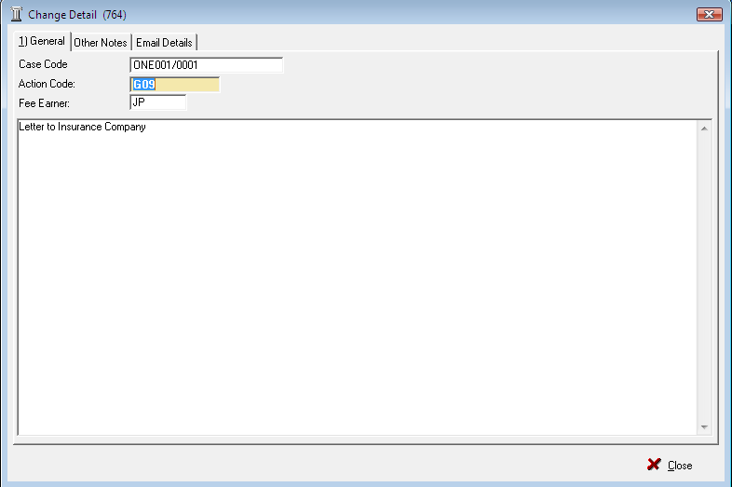Select the task and click the ***view button*** to view details about the selected task.
5. Click the ***Close*** button when complete.

1. Close the remaining screens.

## How to Re-open an Archived Matter

1. Open the ***Archived Matter Screen*** and ***Search*** for the required archived matter.
2. ***Select*** the required matter.

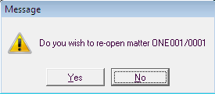

1. Click the ***Re-Open button*** . The following message will appear.

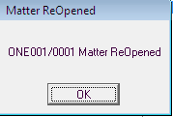

1. Click ***Yes***. The following message will appear confirming the matter has been re-opened.
2. Click ***OK***. The matter is now available in the normal open matter lists.

## How to close a Matter

Before archiving a matter ensure that all balances are nil and all time is posted to the time ledger.

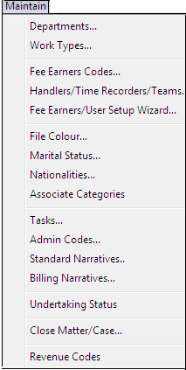

1. Click on ***Maintain*** on the menu bar. The following menu will appear.
2. Click on ***Close Matter/Case.*** The following dialogue box will appear listing all open matters.

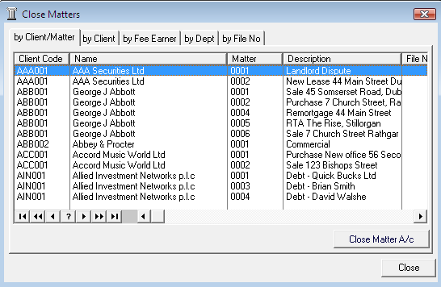

1. ***Type*** in the matter code of the matter you want to close. You will automatically move to the matter.

**Tip** If you type the code incorrectly press page up on your keyboard to reset.

1. ***Select*** the required matter.
2. 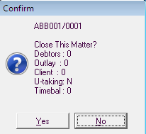Click the ***Close Matter button*** . The following message will appear.
3. Click ***Yes***. The following screen will appear displaying any items recorded in the file manager for this client.

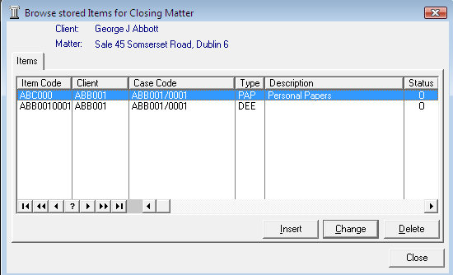

1. See the Chapter 11 on the file manager for further information.
2. Click the ***Close*** button.

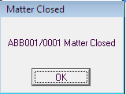

1. A message will appear indicating the matter is now ***closed***.
2. Click ***OK***

## How to Move a Matter

Sometimes matters are setup incorrectly against the incorrect client. The move matter routine allows you to move a matter from one client to another.

1. Click on ***File*** on the menu bar a menu will appear.
2. Click on ***Move Matters***. The following dialogue box will appear.

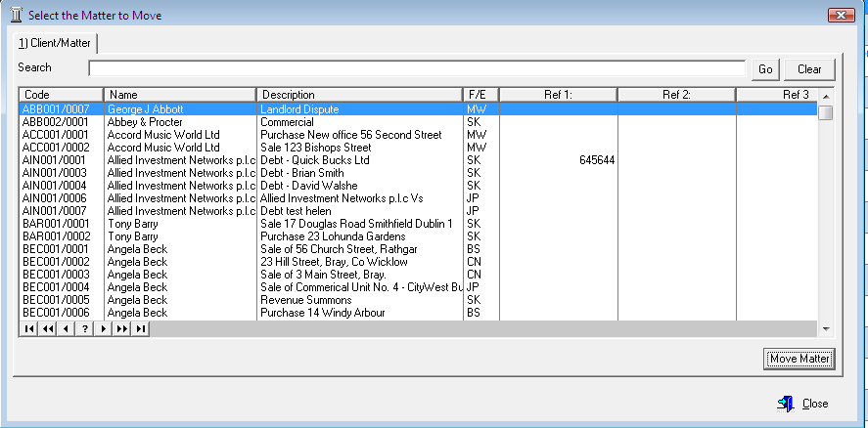

1. Click in the Search box provided. ***Input*** a key search word and Click ***Go***.
2. ***Select*** the required matter.
3. 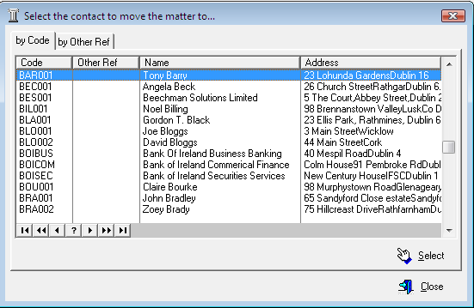Click on the ***Move Matter*** ***button*** . The following dialogue box will appear with a list of clients.
4. ***Type*** in the correct client’s code i.e. Usually the first three letters of the client’s surname. You will move automatically to that client record.

**Tip** If you type the code incorrectly press page up on your keyboard to reset.

1. Click the ***Select*** ***button***  a message will appear asking do you really want to move this matter?
2. 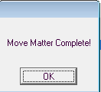Click ***Yes***.
3. A message will appear confirming the matter has been moved. A new case code has automatically been allocated to the matter.