Chapter 4: The Case Diary

## What is a Case Diary

The case diary is the electronic equivalent of the paper file of a case. It displays a case plan to help guide you through a case. A Case Plan is made up of a series of Tasks/Actions; these actions in turn are made up of documents which are processed when a task is taken. The Case Diary records completed tasks, generated tasks and outstanding tasks. It shows the date of the task, the person assigned to the task i.e. the handler and a description of the task. In addition, information on the client and matter details can also be viewed and amended from this screen.

See the following example of the case diary for Case BEC001/003. It is based on the Sale Workflow. It has three tasks in the case diary, two are complete tasks and the other is scheduled for a date in the future.

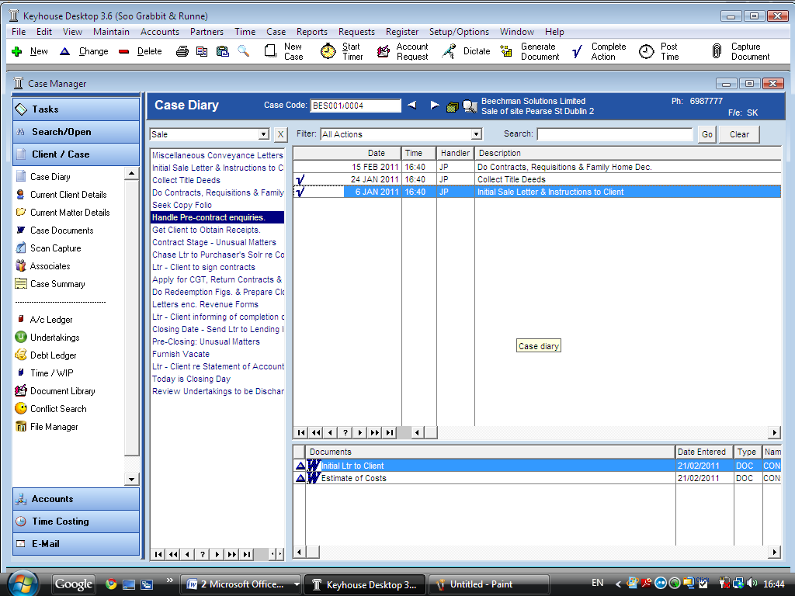

Case Diary showing

1) Task completed

2) Future Tasks

Documents Generated

Actions\Tasks in the Sale Case Plan

Shortcut Bar

## Layout of Case Diary

### The Case Diary Toolbar



|  |  |  |
| --- | --- | --- |
|  | New | Click on the green plus to add any of these tasks. |
|  | Change | Click on the blue triangle to make a change to an action. |
|  | Delete | Click on the red dash to delete an action. |
|  | Printer | Click to print a diary report. |
|  | Copy and Paste | Copy or Paste a Task. |
|  | Document Search | Document Search by Track Reference. |
|  | New Case | Create a new case. |
|  | Start Timer | Click to start the timer for the current case. |
|  | Account Request | Click to request a cheque or a new draft bill. |
|  | Dictate | Click to dictate to the current case.  **See the Keyhouse Digital Dictation Manual for further information on this feature. |
|  | Generate | Click to generate a document for a selected action. |
|  | Complete Action | Click to mark a task as complete. |
|  | Post time | Click to bring up a manual time slip. |
|  | Capture | Capture files or folders –i.e. Import external files into the case. |

### Case Diary Navigation Bar



|  |  |  |
| --- | --- | --- |
|  | Case Code | Case Code of current open case.  ***Or***  To open a case input the case code and press enter. |
|  | Navigation buttons | Move to the previous Case or go to Next Case. |
|  | Recent Matter List | Click to view a list of recently accessed cases. Double click the required case to open. |
|  | Search for Matters | Click to open the advanced search.  See the Chapter 2 for further information. |

### Case Diary Shortcut bar

|  |  |  |
| --- | --- | --- |
|  | Case Diary | Case Diary Screen |
|  | Current client Details | Click on this to view or edit the current client details. |
|  | Current Matter Details | Click on this to view or edit the current case/matter details. |
|  | Case Documents | Click on this to view a list of case documents. |
|  | Scan Capture | Click on this to view a list of Scanned documents to capture. |
|  | Associates | Click on this to view case associates i.e. professionals or parties connected to this case. |
|  | Case Summary | Click on this to view the case summary screen. |
|  | Accounts Ledger | Click on this to view the accounts ledger. |
|  | Undertakings | Click on this to view the undertakings on this case. |
|  | Debt Ledger | Click on this to view the debt ledger. |
|  | Time Ledger | Click on this to view the time ledger. |
|  | Document Library | Click on this to view a list of precedent documents. |
|  | Conflict Search | Click on this to perform a conflict of Interest Search. |
|  | File Manager | Click on this to launch the file manager. |

### Case Diary Symbols

|  |
| --- |
| Tasks in Yellow denote milestone tasks. |
| Tasks with a Red Dot denote a high priority task. |
| Tasks with a Calendar Symbol denote an appointment. |
| Tasks with a Phone Symbol denote a phone call. |
| Tasks with a Broken Yellow Box denote documents processed. |
| Tasks with a Blue Tick denote a completed task. |
| Tasks with a yellow note denote a Note. |
| Tasks with a hand denote a delegated task. |
| Tasks with a blue arrow denote tasks of low importance. |
| Tasks with U denote an Undertaking. |
| Tasks with S denote a Statute of Limitation date or a critical date action. |
| Tasks with an envelope denote an email sent or received. |

## Maintaining Client and Case Records

### Updating Client Details

1. 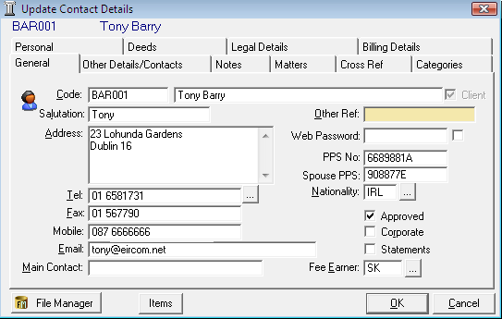***Open*** a case in the ***Case Diary***.
2. Click on ***Current Client Details***  located on the ***Case diary shortcut bar***. The following window will appear.
3. ***Input*** the following information:

General Input/Amend information on the client’s name, address, telephone numbers etc.

Other Details/Contacts Click on ***Other Details\Contacts*** to add additional client contacts for example the client’s spouse or if the client is a company the Managing Director details.

Notes Click on the ***Notes Tab*** to enter notes relating to the client.

Matters Click on the ***Matters tab*** to view a list of all active matters assigned to this client.

Cross Reference Click on ***Cross Ref*** ***tab*** to cross reference the client with another for example a husband and wife.

Categorise Click on ***Categorise*** ***tab*** to add the client to a category.

Personal Tab Click on the ***Personal tab*** to add the client’s personal details for e.g. Date of Birth, Date of Marriage etc

Deeds Click on the ***Deeds tab*** to view the Deeds belonging to this client.

Legal Details Click on the ***Legal Details tab*** to add the legal details about the client. E.g. Legal Name.

Billing Details Click on the ***Billing Details tab*** to add information on the billing details of this client.

1. Click ***OK*** when complete, to update the record.

### Updating Case Details

1. 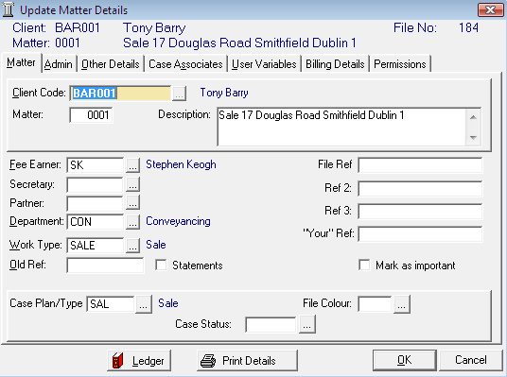***Open*** a case in the ***Case Diary***.
2. Click on ***Current Matter Details***  located on the ***Case diary shortcut bar***.
3. Input the following details:

Matter ***Input/Amend*** any details relating to the matter description, fee earner etc.

Admin Click on the ***Admin tab*** to add an estimate of fees, statute date and billing rate.

Other Details Click on the ***Other Details tab*** to add information specific to this case type e.g. in a conveyancing file the premises for sale or purchase can be entered here.

Case Associates Click on the ***Case Associates tab*** to view existing Case Associates or to add new Case Associates.

User Variables Click on the ***User Variables tab*** to view a list of user variables either already added to the case or due to be added. User Variables answers can also be amended in this tab using the blue triangle.

**Note** these variables are specific to each case plan or document generated.

Billing Details Click on the ***Billing Details tab*** to add information on the billing of this matter.

Permissions Click on the ***Permissions tab*** to control access to this matter, for example to allow only certain groups access.

1. Click ***OK*** when complete, to update the record.

### Inserting a Statute of Limitations Date

1. ***Open*** a case in the ***Case Diary***.
2. 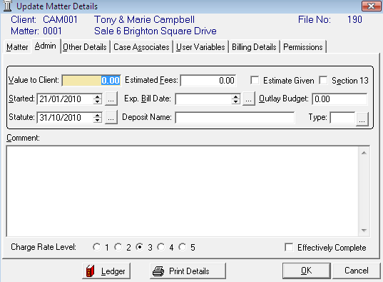Click on ***Current Matter Details*** located on the case Diary shortcut bar.
3. Click on the ***Admin*** Tab.
4. ***Input*** a Statute Date or click on the  ***... lookup button*** to select a date from the calendar. (circled in red)
5. ***Click OK*** to save the changes.
6. The Statute Date will now appear as a task in the Case Diary assigned to the case Fee Earner and dated prior to the actual Statute of Limitations Date for reminder purposes.

All ‘Statute of Limitation Dates’ can be clearly identified by the Statute of Limitation symbol. 

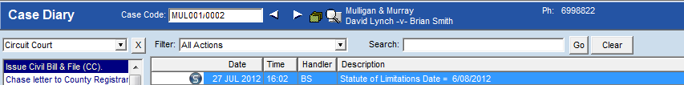

## Case Associates

### What are Case Associates?

Case Associates are all individuals, companies, government departments, courts etc. connected with a case. For example the solicitor, the barrister, the defendant, the purchaser, the land registry, the lending institute etc. to name but a few. By adding case associates to a case you can view their details i.e. name, addresses, telephone numbers etc. in the case associate screen. You will also facilitate the generating of letters to case associates for example a “letter to solicitor” will insert the solicitors name and address.

### How to Add an existing case associate to a case

1. ***Open*** a case in the ***Case Diary***.

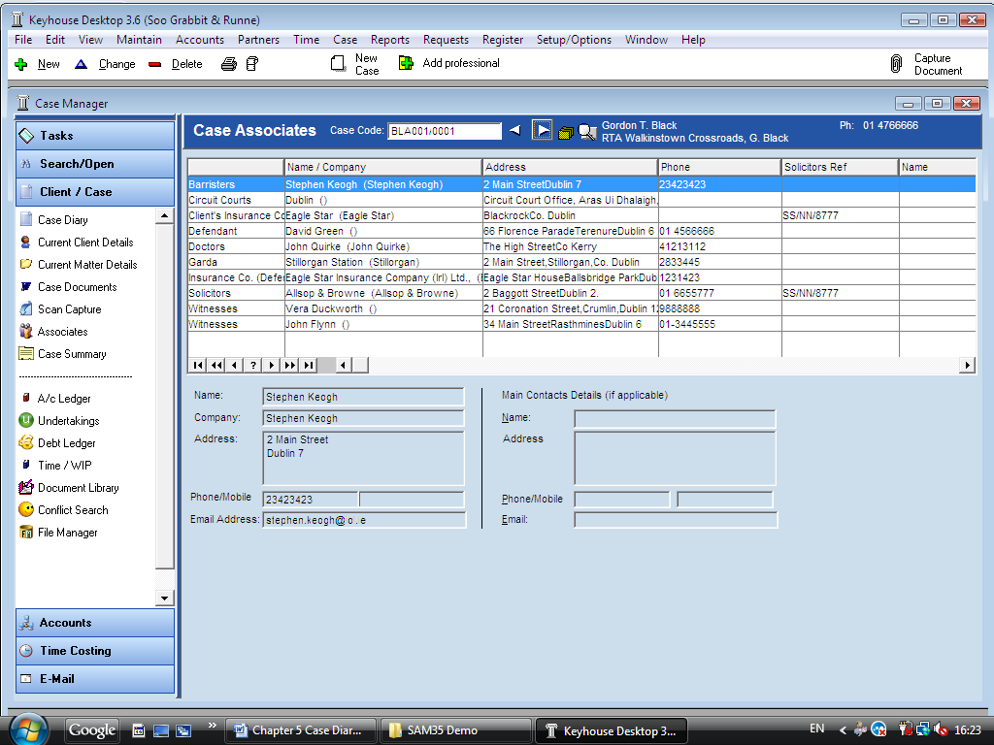

1. Click on ***Associates*** on the ***Case Diary Shortcut Bar*** a list of case associates assigned to case will appear.
2. Click on ***Add Professional***  located on the ***Case Associate toolbar***. The following dialogue box will appear listing categories on the left of the screen and entries on the right.

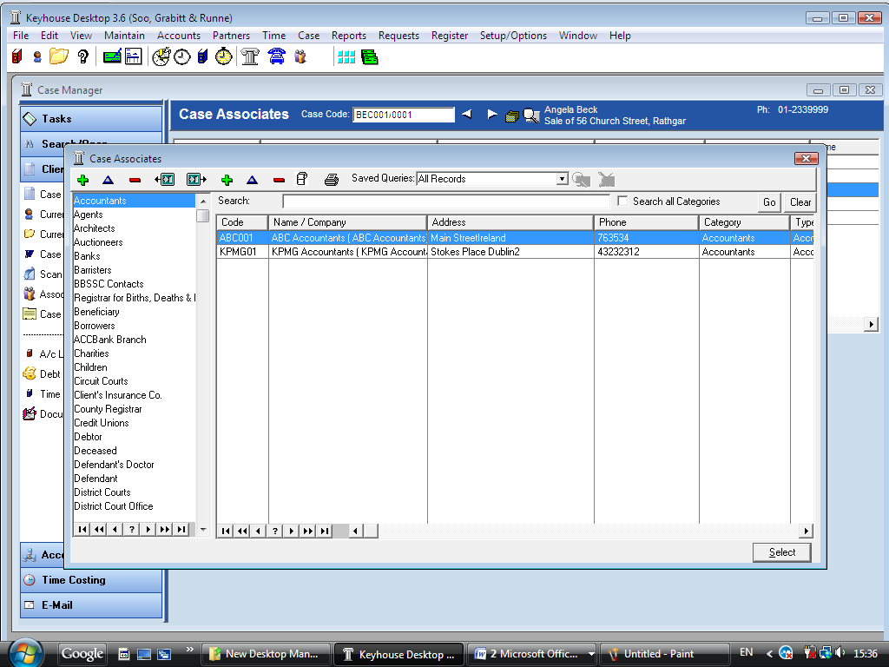

1. 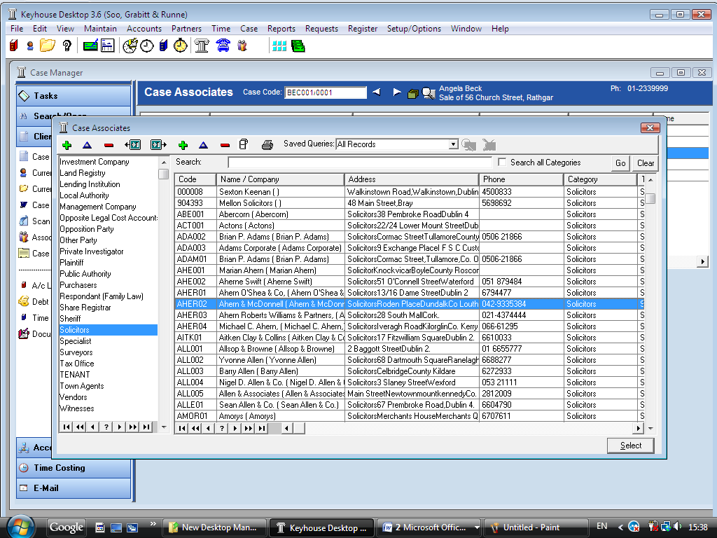Click on the ***category*** of case associate you want to add e.g. Solicitors located on the left of the case associate list.

(circled in red)

1. 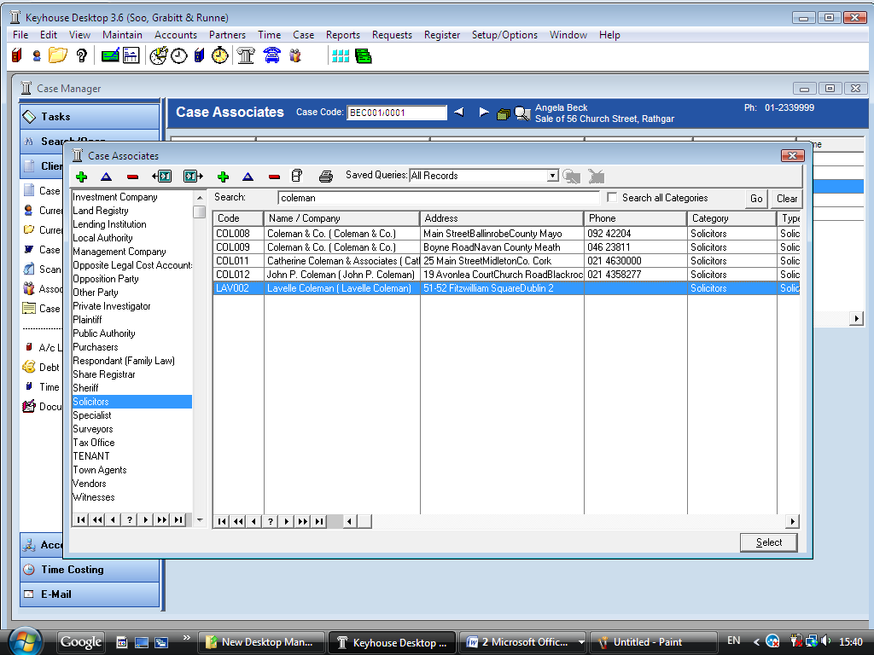Click in the ***Search box*** provided and ***input*** part of the solicitors name
2. Click ***Go***.
3. ***Click*** on the solicitor required and click on the ***select button*** to assign to the case.

**Note**: To search across all Categories put a ***tick*** in Search all Categories.

### How to Add a new case associate to a case

1. ***Open*** a case in the ***Case Diary.***
2. Click on ***Associates*** on the ***Case Diary Shortcut Bar***
3. Click on ***Add Professional*** on the ***Case Associate Toolbar***.
4. Click on the ***category*** of case associate you want to add e.g. Doctor.
5. Click in the ***search box*** provided, ***input*** a key search word and click ***Go.***
6. 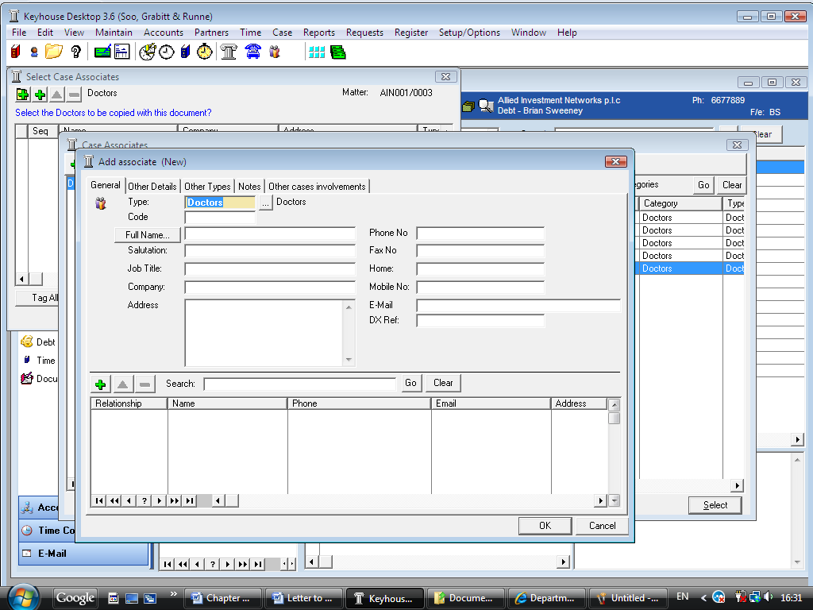If no results are returned you need to add a new record.
7. Then click on the ***green plu*s**  located on the ***Case Associate Toolbar***. The following screen will appear.
8. ***Input*** the relevant information

**Code:** Input a Code for this contact e.g. JAC001 for Dr. Jackson. If you leave the code blank the system will assign a numeric code.

**Full Name:** Input the Full Name

**Salutation:** Input the Salutation

**Job Title:** Input the job title

**Company:** Input the company name

**Address:** Input the address

**Phone No:** Input the phone number

**Fax No:** Input the fax number

**Home:** Input home phone number

**Mobile:** Input mobile phone number

**E-Mail:**  Input e-mail address

**DX Ref:** Input the Document Exchange reference if applicable

1. 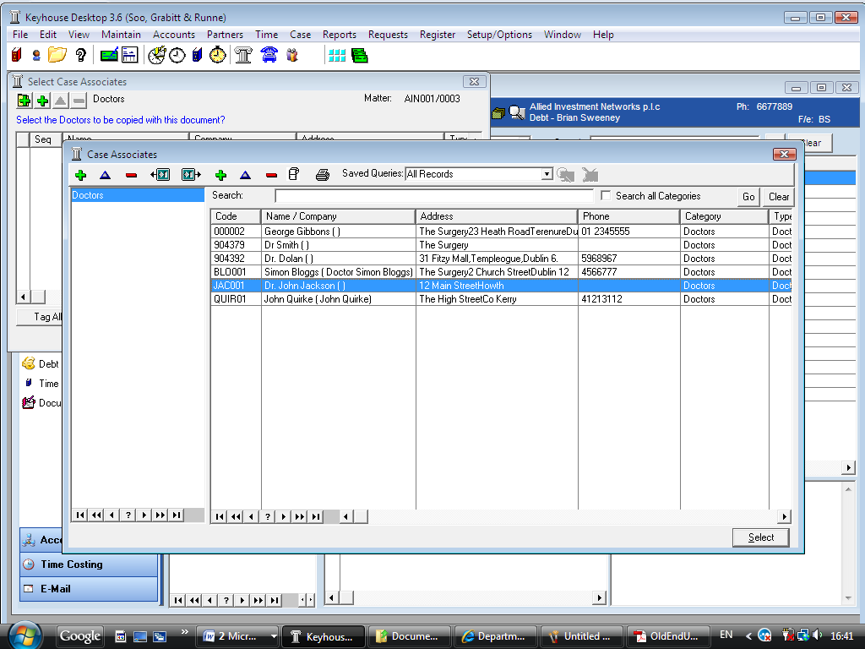Click ***OK***. The following screen will appear showing the new Doctor added to the list of Doctors.
2. Click ***Select*** . The contact will then be assigned to the case and will appear in the case associate list.

### How to Change a Case Associate Details

1. ***Open*** a case in the case diary
2. Click on ***Associates***  located on the ***Case Diary Shortcut Bar***.
3. Click on the **Associate** to be changed.

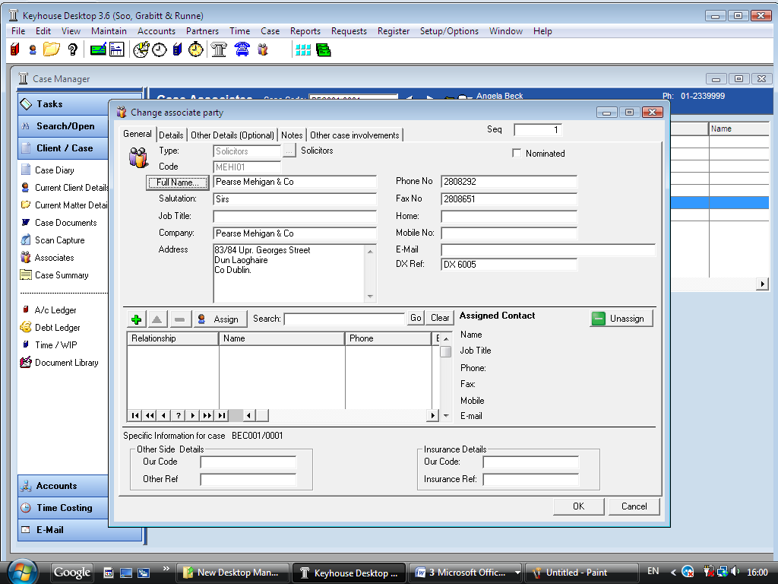

1. Click on the **Change button**  on the ***Case Associate Toolbar***. The following dialogue box will appear.

The section displaying specific Information pertaining to this case (circled in red) will only be visible when amending. This is where the “Other Ref” is inputted.

1. Click on each ***tab*** and amend as required.

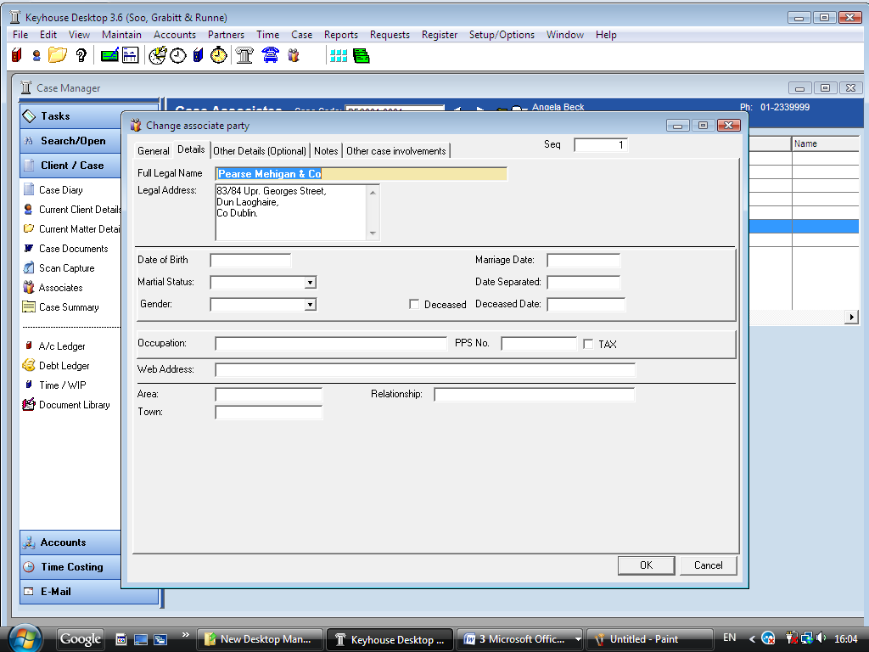

General Click on the ***General tab*** to input/amend details such as name, address etc.

Details Click on the ***Details tab*** to add personal information such as date of birth, occupation etc.

Other Details (optional) Click on the ***Other Details tab*** to add a specific court and court date.

Notes Click on the ***Notes tab*** to add additional notes about the case associate.

Other Case Involvements Click on the ***Other Case Involvements tab*** to view a list of cases this case associate is connected to.

1. Click ***OK*** when complete.

### How to Remove a Case Associate from a Case

1. Click on ***Associates***  located on the ***Case Diary Shortcut Bar***.



1. Click on the ***associate*** to be removed.
2. Click on the ***Delete button***  located on the ***Case Associate Toolbar*** to remove the Case Associate from the case.

**Note**: To remove a case associate completely first remove it from the case and then delete it from the case associates database. Note if you try to delete a case associate that is assigned to a different case you will be prevented.

### Print Options

The following Print options are available on the Case Associate toolbar:

 Click to ***Print*** a report of Case Associates on the Case.

 Select a Case Associate and click to ***Print a Label***.

## Inserting and Generating Tasks

Each matter has a specific case plan assigned to it when it is setup. Each Case Plan is made up of a series of Tasks/Actions; these actions in turn are made up of documents which will be processed when a task is generated. When a task is completed a follow up action maybe inserted in the Case Diary for processing in the future. These tasks will then appear in the users to do list on a specific date as a reminder to be processed.

### How to preview template documents

You can view a template/precedent directly from the case plan in the Case Diary. This will allow you to preview documents before generating.

1. 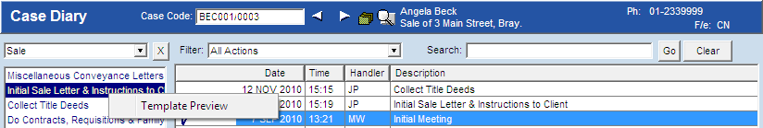***Open*** a case in the ***Case Diary***, the case plan assigned to this case will appear in the case plan section.
2. Click on the ***Action/Task*** you want to preview.

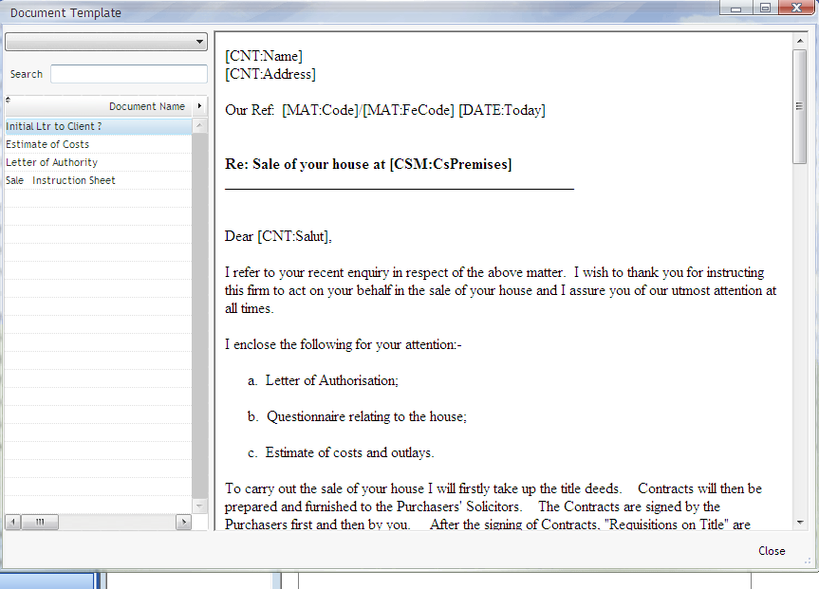

1. Then ***Right click*** over the action the template preview option will appear.
2. Click on ***Template Preview*** to view a list of Documents in this action.
3. Click on each Document to preview. The document will then appear in the right hand preview pane.

***Note***: There is coding in these precedents this will not affect your preview of the document.

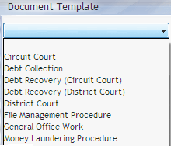

1. To view another case plan and its documents click on the ***drop down arrow***  a list of case plans will appear.
2. Click on the ***Case Plan*** required and preview the documents as before.

### How to Generate a Task

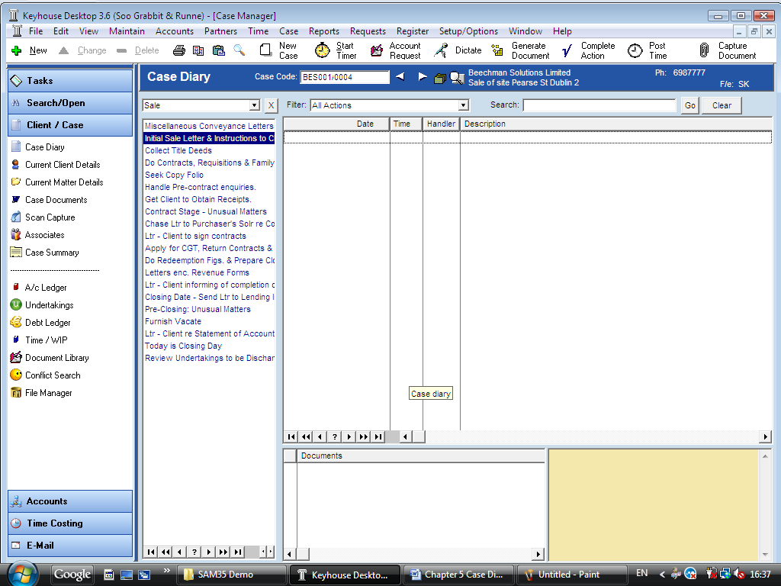

1. ***Open*** a case in the ***Case Diary***.
2. Generate the Task using one of the following methods:

Method 1: ***Double Click*** the task you want to generate from the list of tasks in the case plan or workflow pane.

Method 2: If the task is already in the case diary

1. Click on the task to select it.
2. Click on ***Generate document*** on the case diary toolbar.

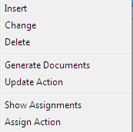**Or**

1. Right click on the task, the following menu will appear
2. Click on generate documents.

## Processing Documents

When a task is generated any precedents connected with the action/task are processed. Depending on how the documents have been setup different requests are made of the user.

Documents are setup with codes; these codes prompt the user for specific information needed in that document.

***What type of information is requested when processing documents?***

1. You may be asked to select the documents you want to process.
2. You may be asked to name the document.
3. You may be asked to insert case associates to the case.
4. You may be asked to answer specific questions pertaining to a particular document

### Select Documents to be processed

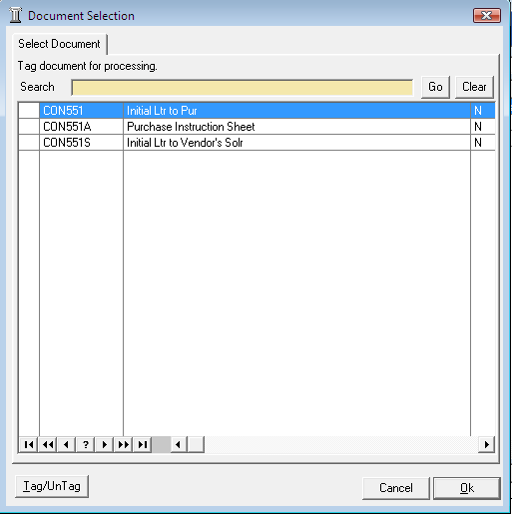

Some tasks are setup with optional documents. Users are given the choice to select the documents they want to process. In this case the following will occur:

1. A  ***Document Selection*** dialogue box will appear.
2. ***Tag*** the documents you want to process by putting a tick next to each document you want to process.
3. Click ***OK*** and the documents tagged will generate.

### Naming and classifying a Document

Some documents are setup with specific names while others may request the user to input a name. If this is the case the following will occur.

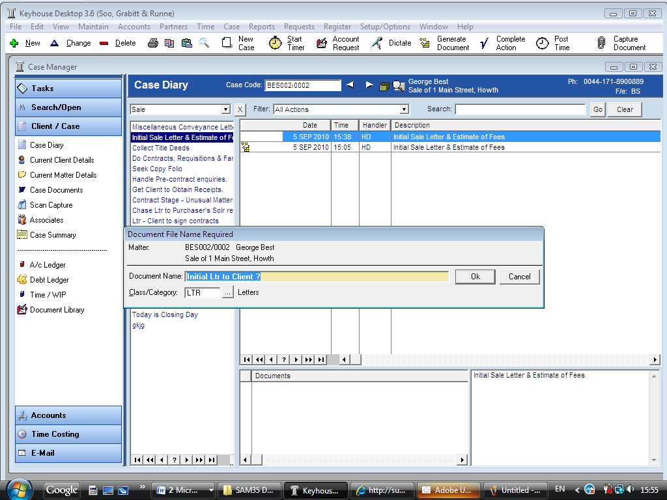

1. The following dialogue box will appear requesting the user to input a document name. ***Input*** an appropriate name.
2. To classify a document click on  ***... lookup button*** and select a document class e.g. Pleadings.
3. Click ***OK***.
4. The system may pause and request information. For example Case Associates or specific questions pertaining to the document.
5. The documents will then be created and displayed in Word ready for printing etc. The documents are saved and stored in the Keyhouse system.

### Adding Case Associates when generating a document

When processing a document you may be asked to add case associates or professionals to a case. Once they are added they are visible in the Case Associates section of the Case Diary.

***Example 1: Letter to Solicitor- Searching and Selecting an existing case associate***

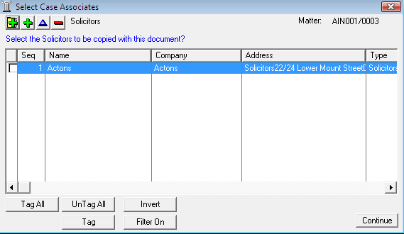In the following example the case associate is a solicitor and the document being processed is a letter to solicitor.

1. The following dialogue box has appeared requesting the user to select a Solicitor for this letter.
2. There is a solicitor already assigned to this case you can tag the solicitor provided then click on the ***amend*** button  to add a reference.
3. ***Input*** the other side’s reference in “Other Ref” (circled in red below)
4. Or if the solicitor displayed is not the solicitor you want to write to click on the ***green plus with the yellow folder*** and add the new case associate as previous outlined in the section on “***How to Add a new Case Associate”.***
5. A screen will reappear listing the solicitors on the case.
6. 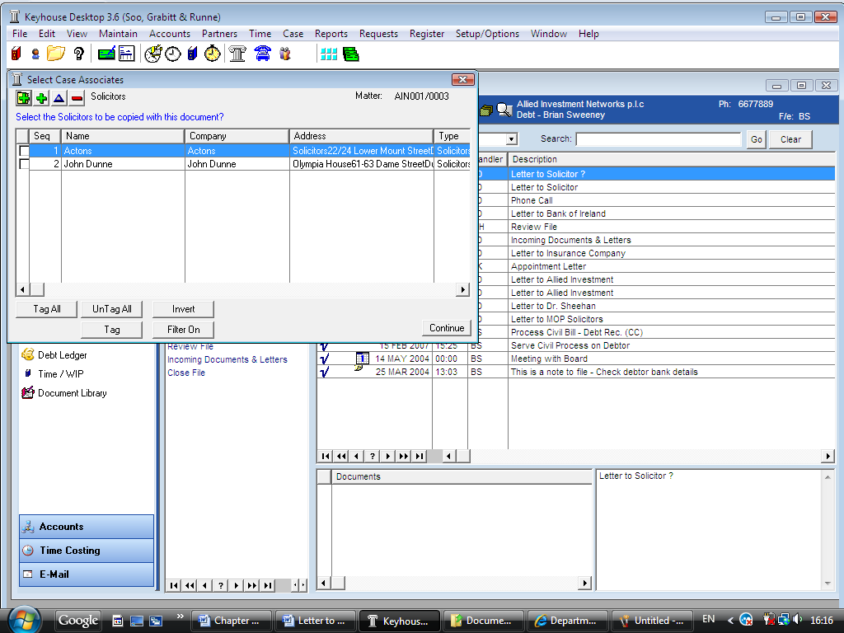Using the tick boxes provided ***tag*** the required solicitor/s. (Circled in Red below)

**Note** If you tag two solicitors two documents will be generated.

1. Click ***Continue***.
2. Word will open displaying the letter to solicitor.
3. ***Edit*** the document in Word as normal as required.
4. ***Save*** any changes and ***Print*** as required.
5. The action/task and document will then be present in the ***Case Diary*** for future review.

***Example 2: Letter to Doctor – Setting up a new case associate***

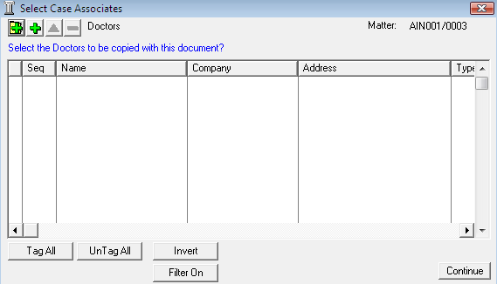In the following example the document being processed is a letter to Doctor, the Doctor is not present in the case associates so he needs to be added to the list of doctors and assigned to the case.

1. The following dialogue box has appeared requesting the user to select a Doctor for this letter.
2. No doctors have been assigned to this case so the user needs to add one.
3. 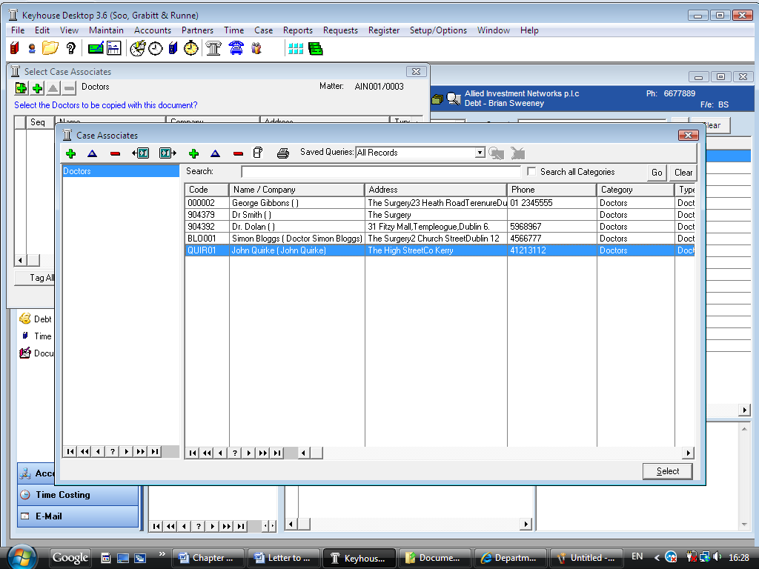Click on the ***Green Plus with the yellow folder***  and the following screen will appear.
4. The doctor the user wants to write to is not available on the list so a new doctor needs to be setup.

***Remember*** to always perform a search to ensure the case associate is not already setup on the system.

1. 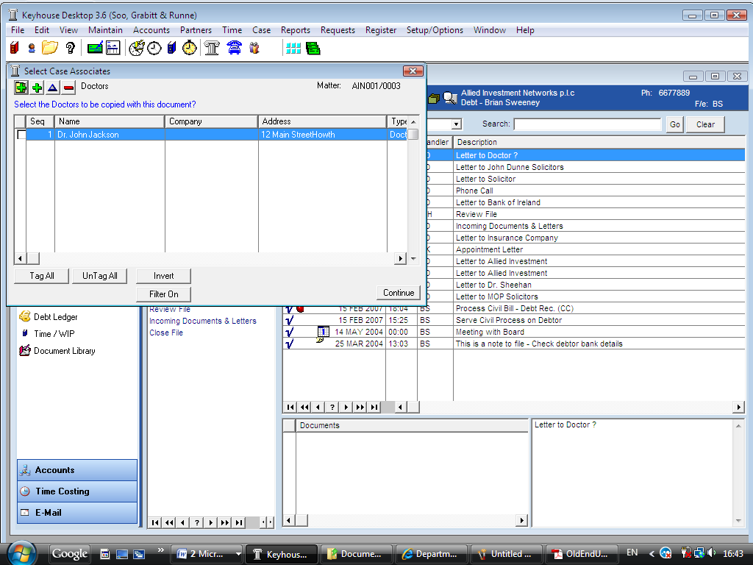Click on the ***Green Plus***  to add the new Doctor. See the section on ***Adding a New Case Associate*** for further details.
2. Then click on ***Select ***. The following screen will reappear listing the doctor assigned to the case.
3. Using the tick boxes provided ***tag*** the required Doctor and click ***Continue***.
4. Word will open showing the letter to doctor
5. ***Edit*** the document in Word as normal as required.
6. ***Save*** any changes and ***Print*** as required.
7. The action/task and document will then be present in the Keyhouse Case Diary for future review.

***Example 3: Letter to Lending Institute – Where there is only one lending institute and its already present in the case associates.***

In the following example the case associate is a Lending Institute and the document being processed is a letter to Lending Institute. The template document has been setup to insert information on the first lending institute.

1. Word Opens automatically displaying a letter to lending Institute the information regarding the case and case associate i.e. the lending institute is inserted automatically. No information is requested as it is already been added to the case associates.
2. ***Edit*** the document in Word as normal as required.
3. ***Save*** any changes and ***Print*** as required.
4. The action/task and document will then be present in the Keyhouse Case Diary for future review.

***Example 4: Warning Letter – Where the precedent document has been setup specifically to ask for information on the 2*nd *Defendant.***

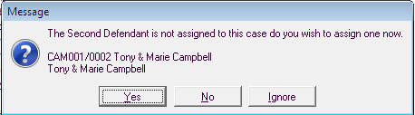

1. The following message box has appeared requesting the user to add a ***Second Defendant*** to the case.

To add a Second Defendant click ***Yes*** and add the case associate as normal then select and add them to the case. (See the previous examples for further information)

**Or**

Click ***No*** if you do not have the information at this time and want to be asked again in the future. In this case any future actions/tasks generated will pause and request this information again.

**Or**

Click ***Ignore*** if you do not have a second defendant on this case and do not want to add one in the future. In this case all future actions/tasks generated will not request this information.

1. Word Opens automatically displaying the warning letter the information regarding the case and case associate is inserted.
2. ***Edit, Save*** and ***Print*** in Word as normal.
3. The action/task and document will then be present in the ***Case Diary*** for future review.

### Answering UDF Questions

When documents are setup they are often setup with Prompts to ask users specific questions pertaining to the document being processed. For example a prompt might ask the user what is the purchase price of the property.

***Example of UDF Question: Sale Price of Property***

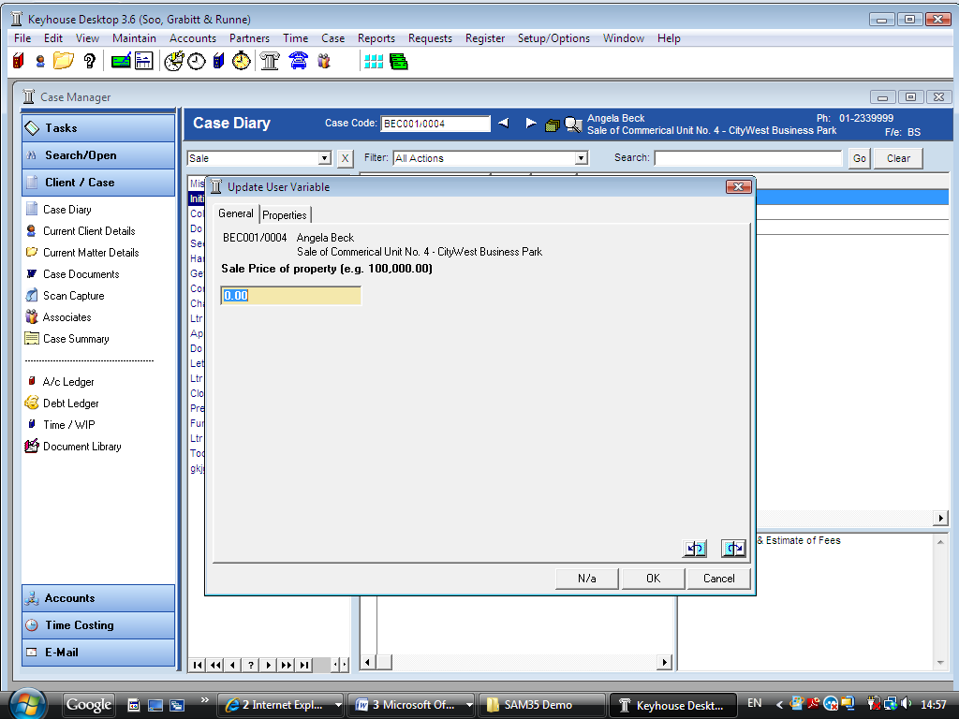

1. ***Input*** the answer in the input box provided.
2. Click ***OK***.
3. If the question is not applicable click ***N/A***.
4. The answer is then inserted in the Word Document.
5. The answer is then stored in the ***User Variables Tab*** of the Current Matter Details for future use and can be view or edited there as required.

## Working with Documents already Processed

### Marking Tasks As Complete

Tasks after being generated  should be marked as complete to reflect this. Otherwise the task will appear incomplete in your to-do list, the case diary and case diary reports. By marking tasks complete follow on actions may be inserted in the case diary. The Case Diary lists outstanding and completed tasks in date order reflecting the progress of the case.

1. ***Click*** on the Task in the Case Diary.
2. Click on ***Complete Action*** on the Case Diary toolbar . The task/action will be marked as complete.



***Note***: The owner of the task is the only person who can mark the task as complete. This allows you to assign a task to another handler but ensures you have ultimate control over it.

If you mark an action as complete any non-generated precedents will automatically generate.

1. A Follow up action is the next task that needs be processed in this case. This is setup by the administrator when the case plan is created. Any follow up actions setup to be ***“automatically processed”*** will be inserted in the case diary automatically.

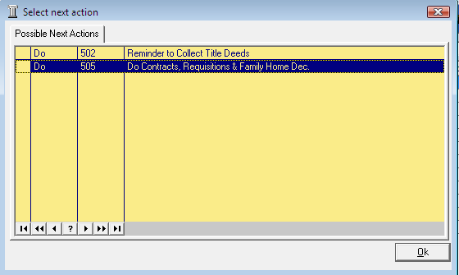**Or**

If the follow up action has been setup to ***“ask the user which action to process”*** the user will be given a choice to insert in the case diary. The following dialogue box appears ***Tag*** the next action/s as required and click ***OK***. The task/s will appear in the case diary.

***Note***: The setup of this section is controlled by your administrator contact him/her regarding setup and timelines.

### Opening Documents Generated

1. In the case diary click on the ***task*** containing the documents. See the following example

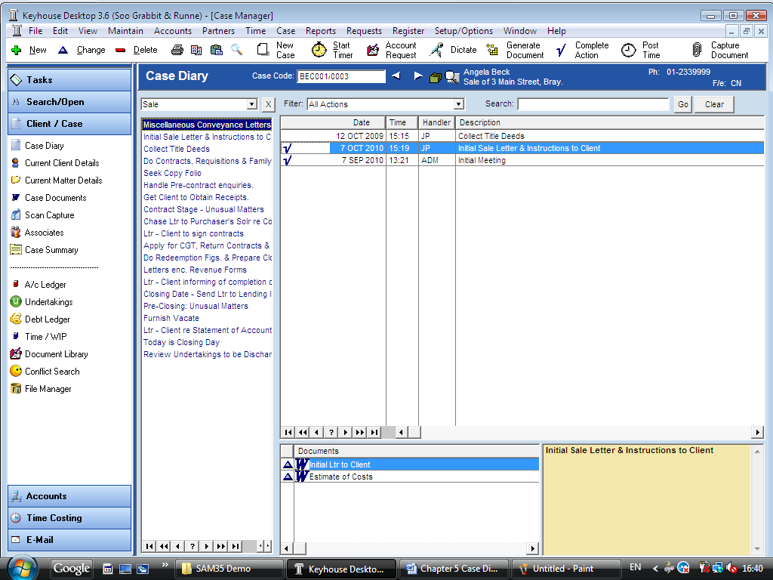

1. ***Double Click*** on the document in the document window. Word will launch and open the document.

### Amending the Name and Class of a Generated Document



* 1. From the document pane in the case diary.
  2. 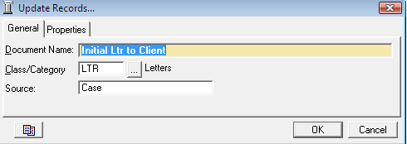***Double Click*** on the ***Blue triangle*** next to the document. The following dialogue box will appear.
  3. ***Amend*** the document name and class as required.
  4. Click ***OK*** when complete.

## Working with Tasks in the Case Diary

### How to Insert Tasks in the Case Diary

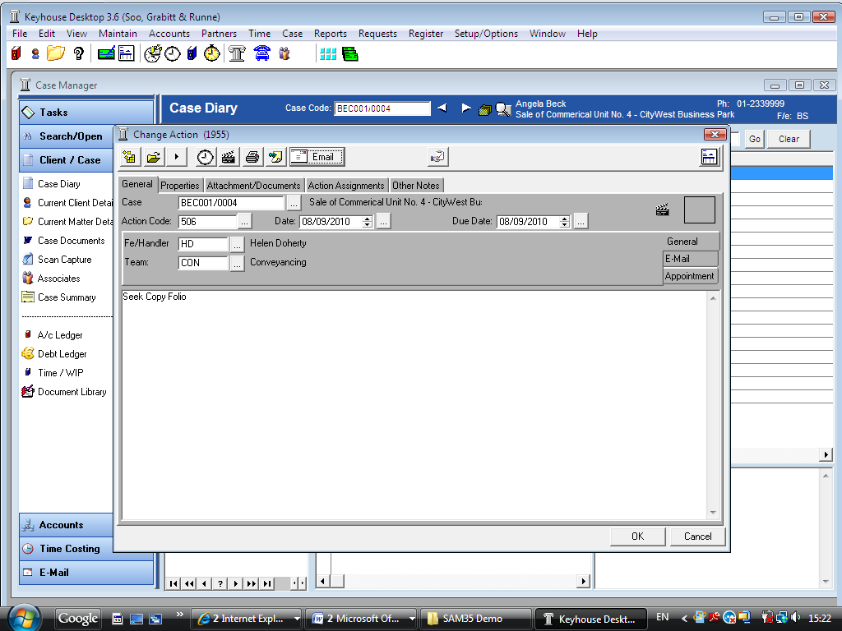

1. To insert the next task in the diary window, ***Click and Drag*** the task from the Workflow to the case diary.
2. ***Double Click*** the Task and change the date for processing. The following dialogue box will appear.

3. Click the ***OK*** Button. This task will then appear in the To Do List Window on that date.

### Changing Actions/Tasks

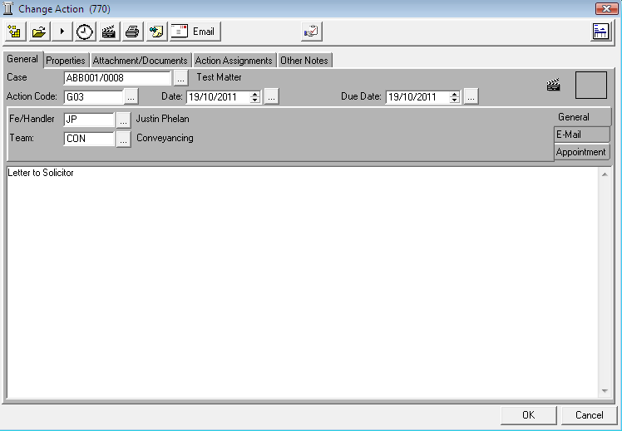At times you may want to amend the details of an action. For instance you may want to amend the action description or assign the action. (For further details see the section on assigning actions).

1. ***Double click*** the task you want to amend and the following dialogue box will appear.
2. ***Amend*** the following details as required
   1. On the ***General Tab*** amend the following details:

Case This will default to the current case to change click on the  ***... lookup button*** and select the required case.

Action Code This will default to the current action code.

Date You can amend the date of task if required. Click on the   
 **... *lookup*** ***button*** to reveal a calendar. Select the required date.

Due Date Click on the  ***... lookup button*** to reveal a calendar select the required due date.

Description Click in the description box and amend as required.

* 1. Click on the Properties tab to reveal the following screen.

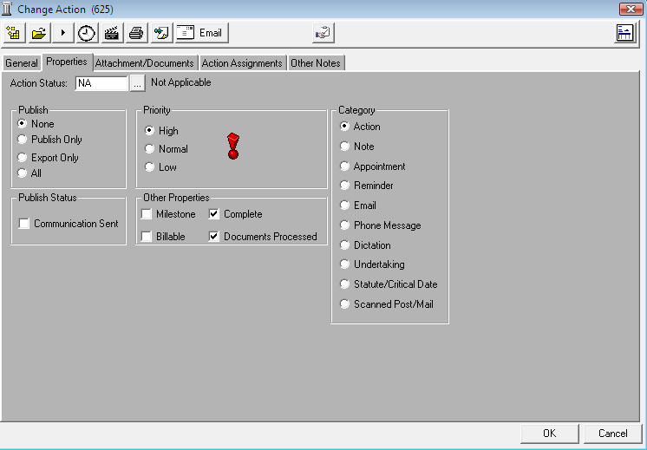

***Amend*** the following details as required:

Action Status Click on the  ***... lookup button*** and select the status of the case when this task is complete. E.g. Pre-Proceedings, Proceedings issued.

Publish This applies only to data that is published to an external source. Using the option buttons ***select*** as required.

Publish Status This applies only to data that is published to an external source. A ***tick*** will appear stating a communication has been sent.

Priority Using the option buttons provided ***select*** the appropriate priority status.

Properties Milestone action ***tick*** if the task is a milestone action

Billable ***tick*** if the task is a billable task.

A ***tick*** will appear in “complete” when the task is completed.

Documents processed a ***tick*** will appear if the task has been processed.

Category Using the ***option buttons*** amend the action category if required.

* 1. 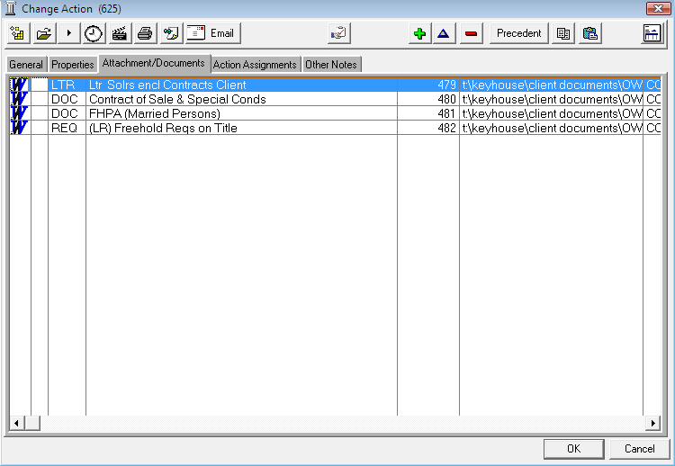Click on the ***Attachment/Documents tab*** to reveal the following screen. A list of documents processed on this task will appear.

The following actions can be performed in this window

#### Open a document



1. Click on the document you want to open.
2. Click on ***Open Document***  located on the change action toolbar.
3. The Word Document will then open in Word to edit, print etc.

#### Add a document to a task

1. 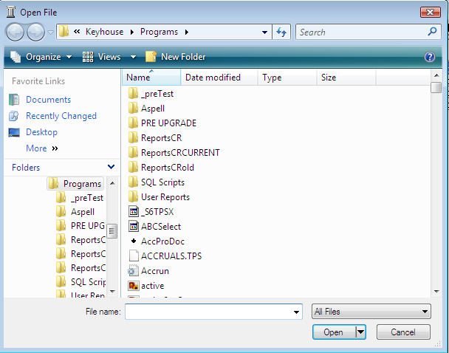Click on the ***Green plus***  located on the change action toolbar. The following dialogue box will appear.
2. ***Browse*** and locate the required document.
3. Click ***OK***. The document will now appear the document list.

#### Amend a documents properties

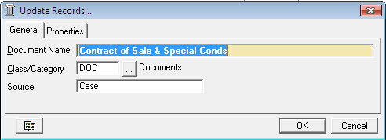

1. Select the document you want to amend.
2. Click on the ***blue triangle***  located on the change action toolbar. The following dialogue box will appear.
3. ***Amend*** the following details as required

Document Name Click in the ***input box*** and amend as required.

Class/Category Click on the  ***...lookup button*** a list of document classes will appear select the required category. E.g. Letter, Pleadings, Inter-Party Correspondence etc.

1. Click ***OK*** to save the changes.

#### Delete a document

1. Select the document you want to delete.
2. Click on the red minus  located on the change action toolbar.
3. Click OK to confirm the deletion.

#### Copy and Paste a document

1. Select the document you want to copy.
2. Click on Copy located on the change action toolbar.
3. Open the task you want to Paste the document in. Click on the Attachment/Documents Tab.
4. Click Paste located on the change action toolbar. A copy of the document will then appear in the document list.
   1. 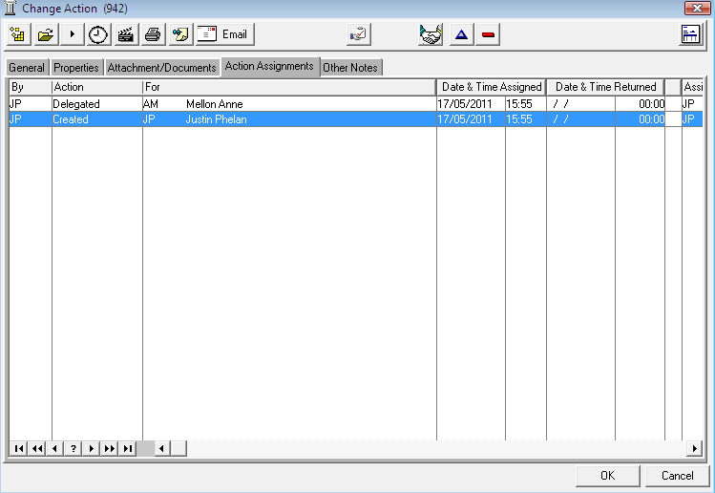Click on the ***Action Assignments tab*** to show the assignment history of the task. See the section on ***Assigning Tasks*** for further information.

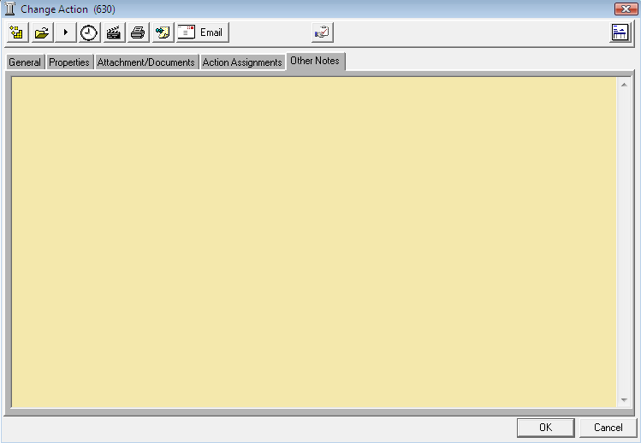

* 1. Click on the ***Other Notes*** tab the following screen will appear. ***Input*** any notes you may have on the task.

1. Click ***OK*** to save any changes made.

### Delete Tasks

1. ***Select*** the task to be deleted from the Case Diary.
2. Click on the ***Red Minus*** (Top left) located on the ***Case Diary Toolbar***.
3. You will be asked to confirm the deletion. Click ***Yes***. If the task has been generated you will be asked if you want to delete the documents generated click the ***Yes*** Button.

### Copying Tasks

1. Click on the Task to be copied from the case diary window.
2. Click on C***opy***  (Top left) located on the case diary toolbar.
3. Click on ***Paste***  (Top left) on the case diary toolbar to paste. This task is now available to be amended and use as required.

### Assigning a Task to Another Handler

1. ***Insert*** the task in the case diary.
2. ***Right click*** on a task a menu will appear

Click on ***Assign Action***.

***Or***

***Double Click*** the task the following screen will appear. Then click on the ***Assignment Tool*** on the ***Change Action Toolbar***.

1. 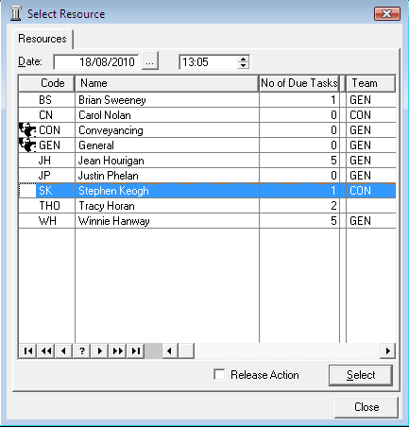A screen will appear listing all handlers.
2. ***Select*** the handler you want to assign the task.
3. Put the ***tick*** in the ***Release Action tick box*** to remove the task completely from your task list. Alternatively to continue to ***own*** the task ***do not*** put the tick in the ***release tick box***.

***Note*** The owner of the task is the only person who can mark the task as complete. This allows you to assign a task to another handler but ensures you have control over the task.

## Undertakings

### Viewing Undertakings

1. ***Open*** a case in the ***Case Diary.***
2. Click on ***Undertakings*** available on the ***Case Diary Shortcut Bar*** (circled in Red below).

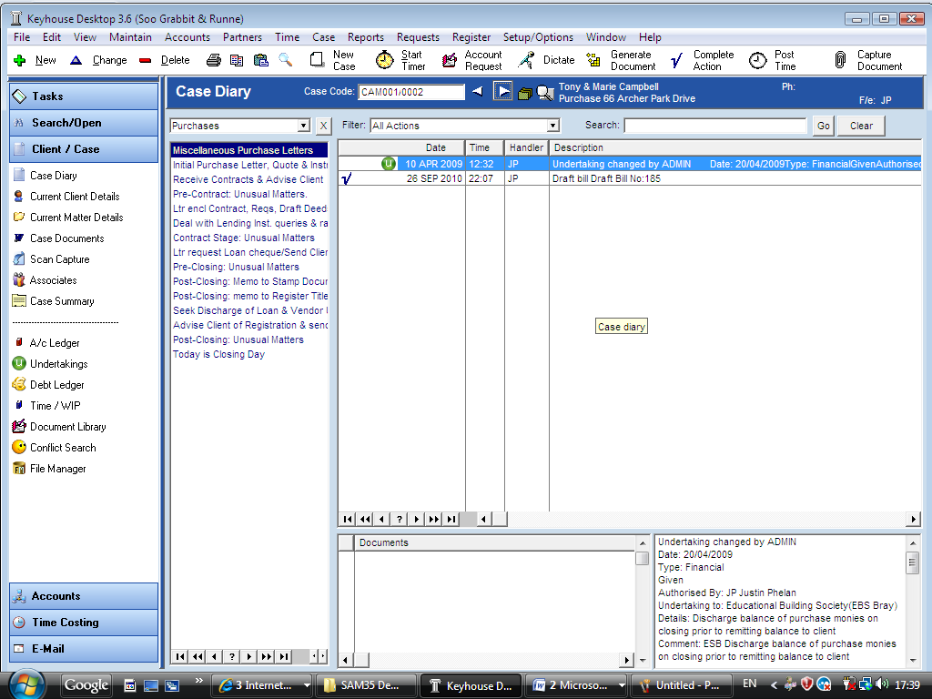

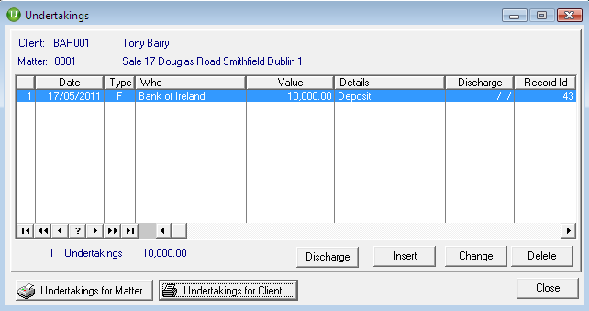

1. The ***Undertaking dialogue box*** will appear displaying any undertakings on this case.
2. ***Select*** the undertaking and click on ***Change*** to view the undertaking.

### Inserting an Undertaking

1. 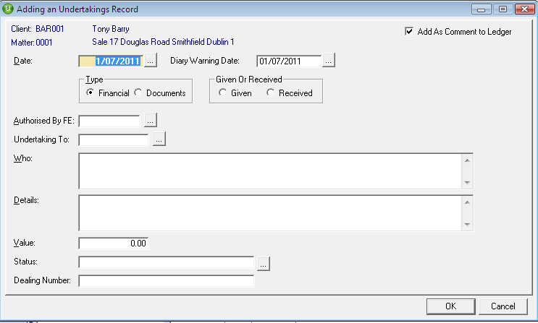Open the ***Undertaking*** screen.
2. Click on ***Insert***  the following screen will appear:
3. ***Input*** the following Information

* Date This is actual date of the undertaking. Click on the  ***...lookup button*** to view the calendar and select a date.

* Warning Date This is the date the Undertaking Action will appear on the Fee Earners Task List as a To Do Item. This will default to a system warning date to amend click on the  ***...lookup button*** to view a calendar and select a date.

* Type Using the option buttons select the type of undertaking i.e. Financial or Documents.

* Given or Received Using the ***options buttons*** select if the undertaking has been given by you or received by you.

* Authorised by FE Click on the ***... lookup button*** to select the relevant Fee Earner against the undertaking.

Undertaking to Click on the  ***... lookup button*** to select the relevant Case Associate of this undertaking. You can add a new Case Associate at this time if required.

* Who This will default to the selected case associate.

Details ***Input*** a description of this undertaking.

* Value ***Input*** the amount the undertaking is for.

Status Click on the  ***... lookup button*** a list of Statuses will appear select the required status.

Dealing Number ***Input*** the dealing number

***\* Required information***

1. Click ***OK*** to save the undertaking and any changes. The Undertaking will now appear as a Task in the Case Diary assigned to the selected Fee Earner dated with the Warning Date.

All Undertakings can be clearly identified by the Undertaking symbol 

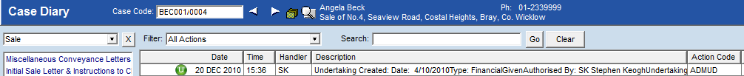

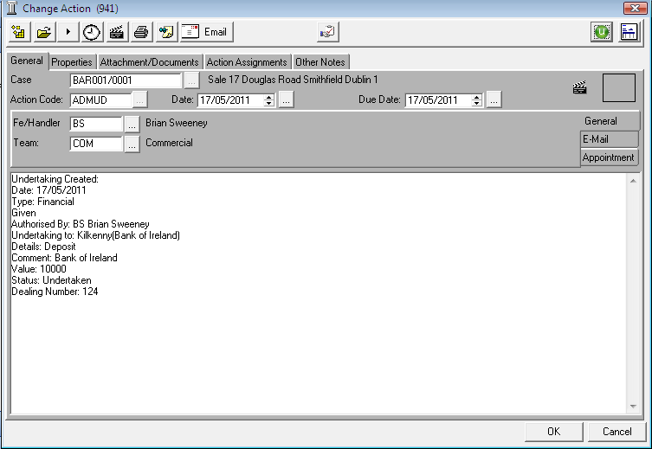

1. To view the Undertaking task, ***double click*** or click on ***change***  the following Change Action dialogue box will appear.
2. To open the ***Undertaking*** click on the ***Undertaking symbol***  located on the change action toolbar. (circled in red above) The following Update Undertaking dialogue box will appear.

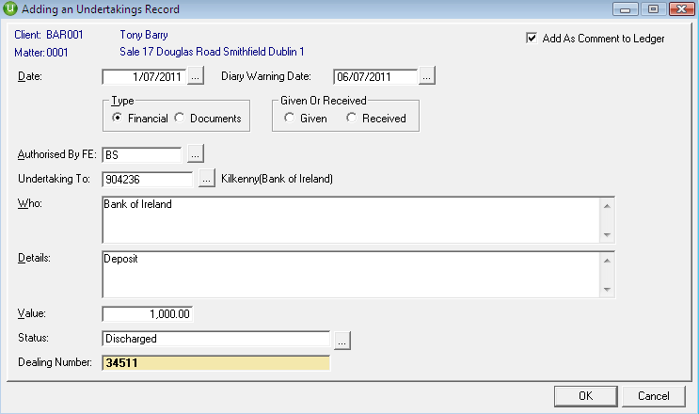

1. Click ***OK*** to save the changes and return to change action screen.
2. Click ***OK*** to save and close.

### How to Discharge an Undertaking



1. ***Open*** the undertaking screen.
2. ***Click*** on the undertaking to be discharged.
3. Click on the ***Discharge button*** (circled in red)

**Note**: Not all users will have permissions to discharge an undertaking.

### Undertaking Reports

|  |  |
| --- | --- |
|  | Click on ***Undertakings for Matter*** to run a report listing all undertakings on the current matter. |
|  |  |
|  | Click on ***Undertakings for Client*** to run a report listing all undertakings for the current client. |
|  |  |

## Case Summary

1. 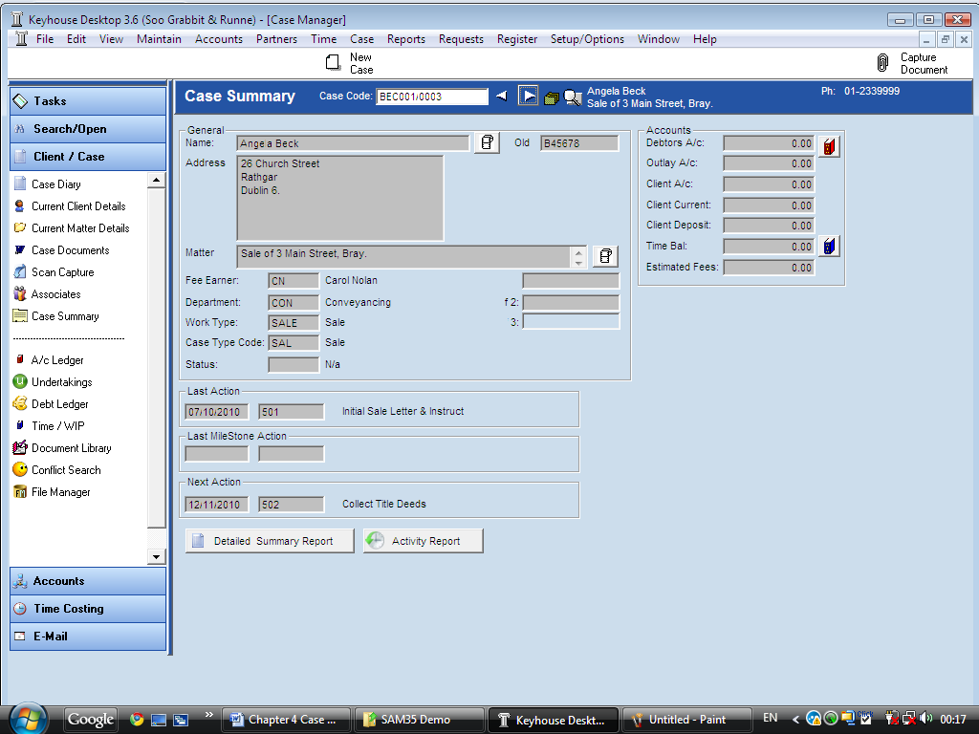***Open*** the required case in the Case Diary
2. Click on ***Case Summary*** on the ***Case Diary Shortcut Bar***. The following screen will appear displaying a summary of the case.
3. To ***Print*** a detailed summary report click on ***Detailed Summary Report*** or to run an activity report click on ***Activity Report***. 

## Diary Report

1. ***Open*** the required case in the Case Diary
2. 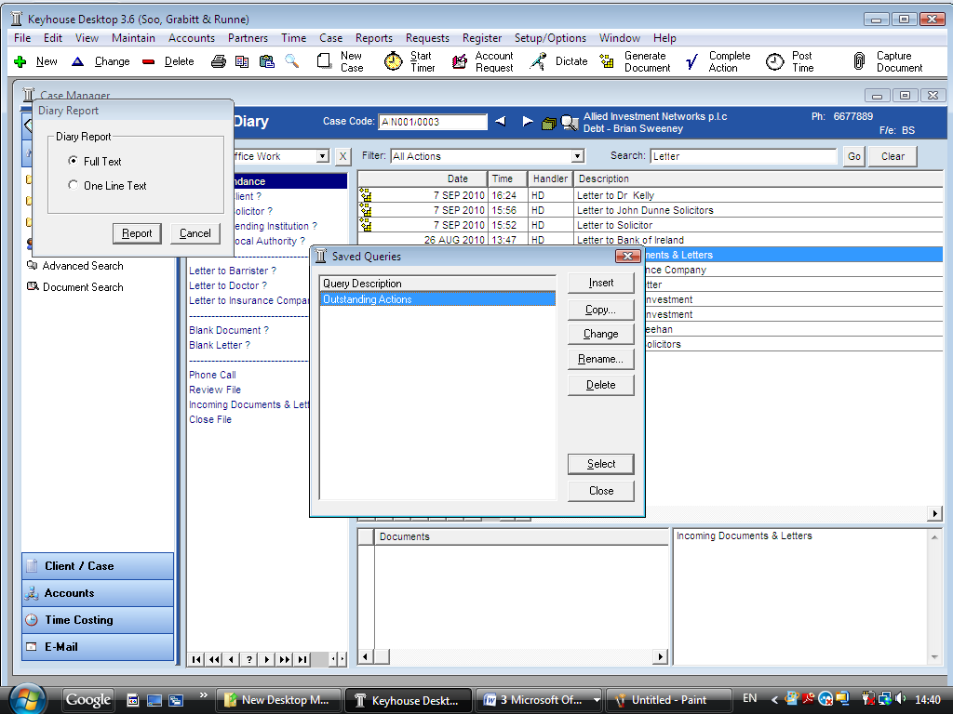Click on the ***Print button*** on the ***Case Diary Toolbar*** a message box will appear.
3. ***Select*** either full text or just one line text.
4. Click on ***Report***.
5. A ***Queries dialogue box*** will appear.
6. Click ***Close*** if you do not want to apply a filter or click on the required filter and click ***Select*** to apply the filter.
7. The Report will then appear. See the following sample ***Diary Report*** showing all tasks showing one line of text.

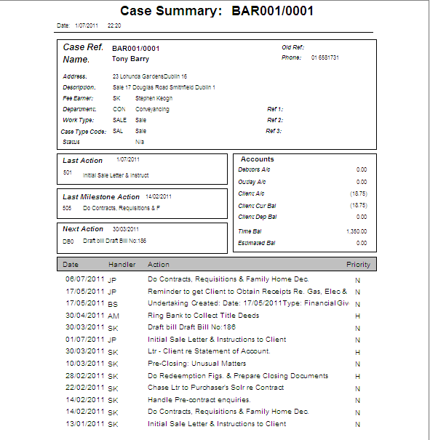

## Case Diary Search Options

### Searching by Track Reference

**Note**: All documents created are allocated a unique track reference.

1. Click on ***Search***  located on the case diary toolbar.

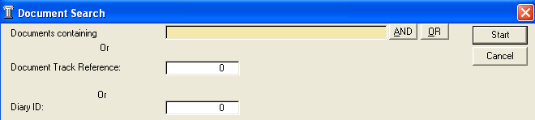

1. A ***Document Search*** dialogue box will appear.
2. ***Input*** the ***Track Reference***
3. Click ***Start***.
4. The document with the track reference will open.

### Searching by Action ID

**Note**: Every task in the case diary is allocated a unique diary ID. It can be found on each task in the case diary.

1. Click on ***Search***  on the case diary toolbar.



1. A ***Document Search*** dialogue box will appear.
2. ***Input*** the Diary ID
3. Click ***Start***.
4. The action will then open in the corresponding case diary.

### Search for a Word in a document

1. Click on ***Search***  on the ***Case Diary Toolbar***.
2. A ***Document Search*** dialogue box will appear.
3. ***Input*** the key search words in the ***Search box*** provided.
4. Click ***Start***.
5. A list of documents containing that word will appear. For more information see the section on the Document Search in Chapter 2.

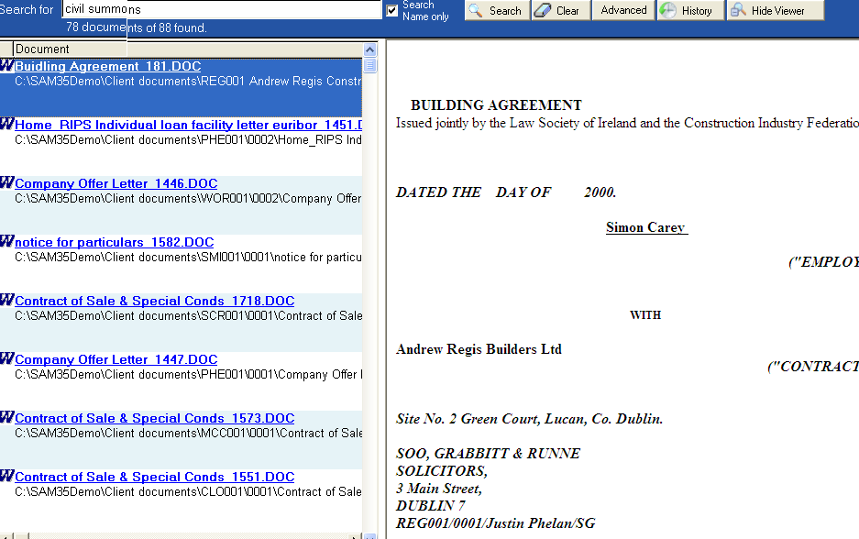

### Search the Case Diary

1. ***Open*** a case in the ***Case Diary.***
2. ***Click*** in the Search box provided.



1. ***Input*** the key search words.
2. Click ***Go***.
3. All tasks containing the search criteria will be displayed in the case diary below. See the following example of a search for “contract”.

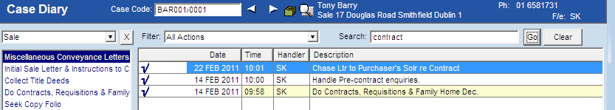

1. Click ***Clear*** to reset

### Filtering the Case diary

1. 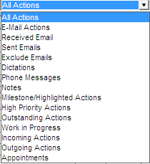***Open*** a case in the ***Case Diary.***
2. Click on the ***filter drop down arrow*** on the ***case diary toolbar*** a list of filters will appear. See the following sample list.
3. Click on the required ***filter***.
4. The ***results*** will appear in the ***case diary below***.
5. To return to all tasks click on the ***filter arrow*** and select ***All Actions.***

### Other Case Diary Functions

See the following Chapters for information on the following functions available in the Case Diary:

* Chapter 6 for the Keyhouse Capture
* Chapter 7 for the Document Library
* Chapter 8 for the Document Manager
* Chapter 9 for Briefs
* Chapter 10 for the Conflict Search
* Chapter 11 for the File Manager
* Chapter 12 for Time Recording
* Chapter 13 for Accounts