Chapter 5: The Task List

When the Keyhouse Desktop is launched it automatically defaults to your Task list. The primary function of the Task List is to act as a To-Do list listing all tasks outstanding. It automatically defaults to overdue tasks but you can navigate to specific dates. Each task will show the date of the task, the matter description, the client name and a description of the task itself.

## Navigating the Task List

### The Task Screen

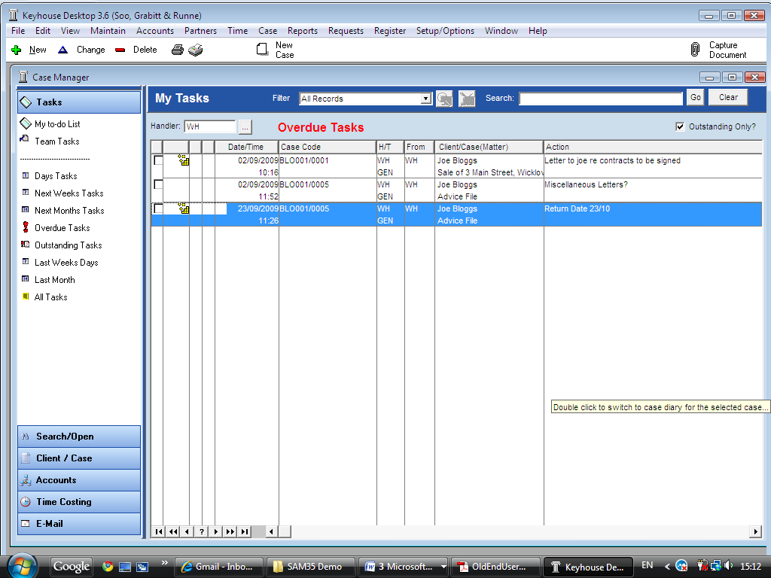

Shortcut Bar

Task Views

Search box

To-Do List

Task Toolbar

Filter list

### The Task Toolbar

|  |  |
| --- | --- |
|  | New Task |
|  | Change Task |
|  | Delete Task |
|  | Print Handler Report |
|  | Handler User Defined Reports |
|  | The New Case Wizard is available on the Task Screen for information on the New Case Wizard See Chapter 2 for details on how to open a new case |

### Task Views

The Keyhouse Desktop will automatically open on Overdue Tasks. The user may choose to navigate to any of the following lists displayed on the shortcut bar on the left.

|  |  |
| --- | --- |
|  | Click on My to do list to view the current handlers tasks or click on team tasks to view the team tasks |
|  | Click on this to view a today’s tasks. |
|  | Click to view next week’s tasks. |
|  | Click to view next month’s tasks |
|  | Specify a date range using the from and to  …lookup buttons |
|  | Click to view overdue tasks |
|  | Click to view outstanding tasks i.e. past, present or future. |
|  | Click to view Last Weeks outstanding tasks. |
|  | Click to view Last Months outstanding tasks. |
|  | All Tasks shows all outstanding tasks |

### Searching the Task list

1. ***Input*** key search words in the ***Search box provided*** and click ***Go***. The search will search the task/action description.
2. The results will appear in the task screen. See the following example of a search for “title” in the task list.

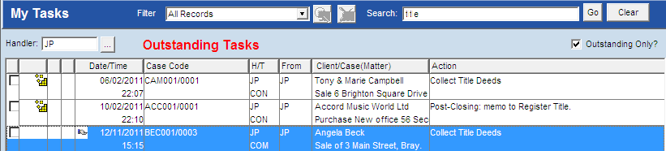

1. To clear the search results click ***Clear***.

### Filtering the Task List

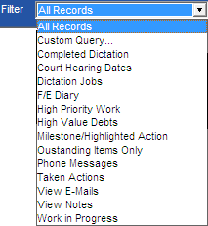

1. Click on the ***filter arrow*** on the ***tasks toolbar*** to display a list of filters.

**Note** these filters are specific to each firm contact your administrator if you require any new filters.

1. Click on the ***filter*** required.
2. The ***results*** will appear in the ***task screen*** below.
3. To return to all tasks click on the ***filter arrow*** and select ***All Records.***

### Accessing a Case Diary from the Task List

1. Double click the task of the case required.
2. Automatically you will move to the case diary screen of the selected task.

## Processing Tasks

## Generating Documents

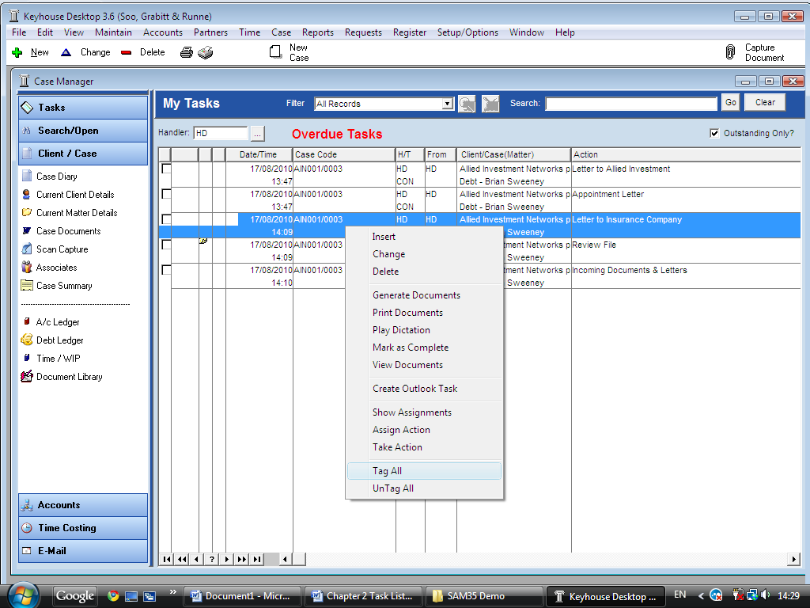

1. ***Right click*** on the task you want to generate. The following menu will appear.
2. Click on ***Generate Documents***. The documents will generate as standard. For further information see the section on generating documents in Chapter 4.

### View the Documents of a Task

1. ***Right click*** on a task a menu will appear.
2. Click on ***View Documents*** the documents will open in Word.

### Marking a Single task as Complete

1. ***Right click*** on the task you want to mark as complete a menu will appear.
2. Click on ***Mark as Complete***.

**Note** if the task has not been generated it will generate at this time.

### Tag Several Tasks and Mark as Complete

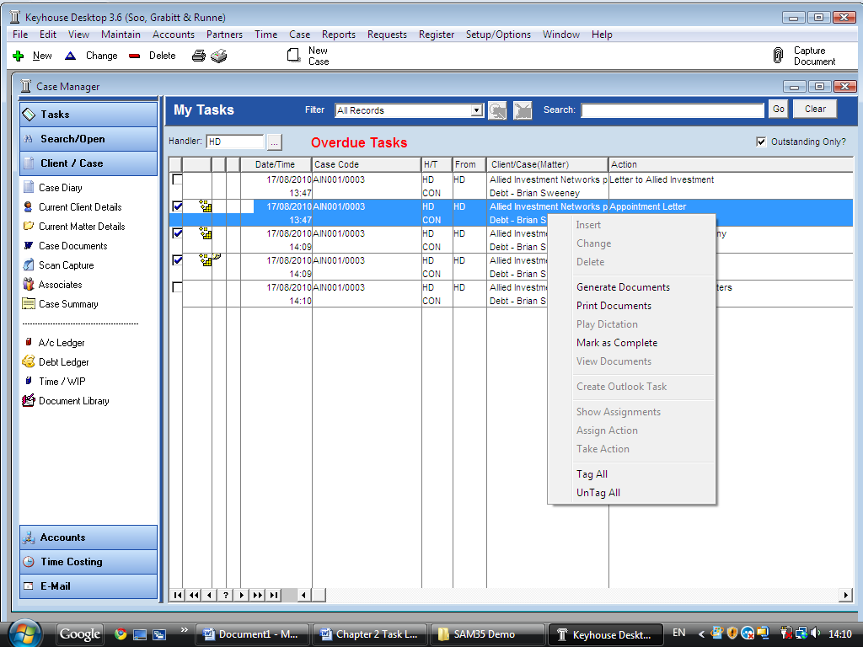

1. ***Tag*** the tasks you want to complete using the ***tick box*** next to each task. See the following example.
2. ***Right click*** in the task list for the menu to appear. See the menu above.
3. Click on ***Mark as Complete.***

### Tag All Tasks

“Tag All” will tag all actions in your task list then you can mark the actions as Complete, Generate Documents, View Documents or Print Documents.

1. ***Right click*** in the task list, a menu will appear.



1. Click on ***Tag All***.

**Tip**: To UnTag click on ***UnTag All***

1. Then ***Right click*** again in the task list the same menu will appear.
2. Click on the required function e.g. ***Mark as Complete***.

### How to Add a New Task

1. ***Right click*** on the task list a menu will appear.
2. 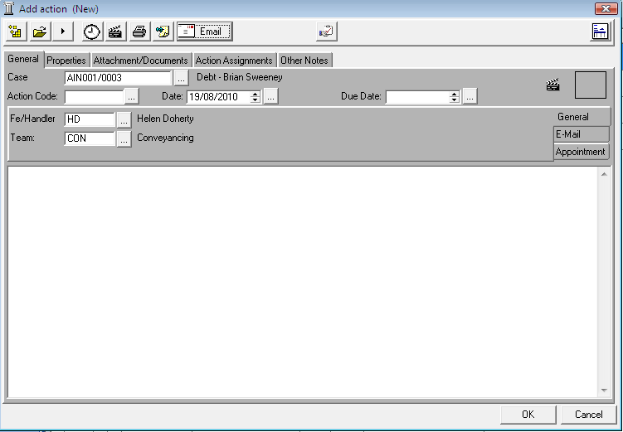Click on ***Insert***. The following window will appear.
3. ***Enter*** the following details:

***Case*** The current case code will appear to amend click on the  ***…lookup button*** a list of cases will appear. Select the required case.

***Action Code*** Click on the  ***… lookup button*** a list of tasks will appear select the required task.

***Date*** The date will default to today’s date amend if required by clicking on the  ***… lookup button***.

***Fe/Handler*** The handler will default to your initials amend if required using the

 ***… lookup button***.

***Team*** The team will default to your team amend if required using the

 ***… lookup button***.

1. Click ***OK*** to save the changes.

### How to Amend Tasks

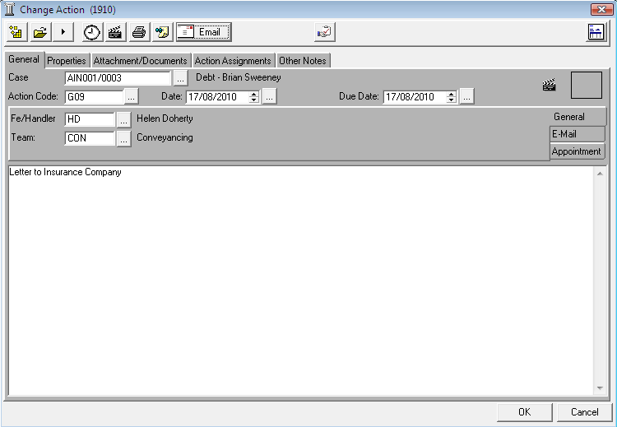

1. ***Right click*** on the task to be amended a menu will appear.
2. Click ***Change*** the following screen will appear.
3. Amend as required and click ***OK***.

### How to Delete Tasks

1. ***Right click*** on the task to be deleted a menu will appear.
2. Then click on ***Delete*** a message will appear.
3. Click ***Yes***.

**Note**: This will delete the action completely from the Case Diary of the matter.

## Assigning Tasks

### How to Recognise Assigned Tasks

If another handler assigns you a task it will appear in your Task List. It may have a hand symbol  next to the task to notify to you that it is an assigned task. See an example below



**Note** If you are assigned a task process and complete the task as normal. For further details see ***Chapter 4: Working with Tasks - Assigning Tasks to another User***.

### Viewing the Assignment History of a Task

1. ***Right click*** on the task a menu will appear.
2. Click on ***Show assignments***. The following screen will appear displaying the history of the task.

### Assigning a Task to Another Handler

1. ***Right click*** on a task a menu will appear
2. Click on ***Assign Action***. The following screen will appear listing all handlers.
3. 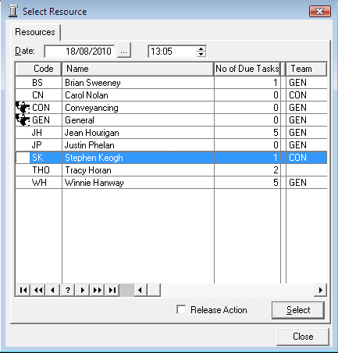***Select*** the handler you want to assign the task.
4. Put the ***tick*** in the ***Release Action tick box*** to remove the task completely from your task list. Alternatively to continue to ***own*** the task ***do not*** put the tick in the release tick box.

***Note***

Complete the task as normal it will disappear from your to do list. If you are the owner of the task you will see when the assigned user has completed the task. The following symbol  will appear next to the task in your to do list. As the owner you are the only person who can mark the task as complete in the case diary.

## Reports

### Print a Handler Diary report by Query

1. Click on ***Print***  on the ***task toolbar***. The following menu will appear.
2. Click on ***Handler Diary Report***. The following window will appear.

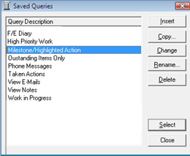

**Note** these Queries are specific to each firm contact your administrator if you require any new queries.

1. ***Select*** the report you want to print from the ***saved queries list***. If you do not want to apply any of the queries click ***Close*** a report will generate showing all tasks on your to do list.
2. Click ***Select***. The report will generate and appear on your screen
3. To print click on ***Print***  on the ***Report Preview toolbar***.

### Print a User Diary Report

1. Click on ***Print***  on the task toolbar. The following menu will appear.

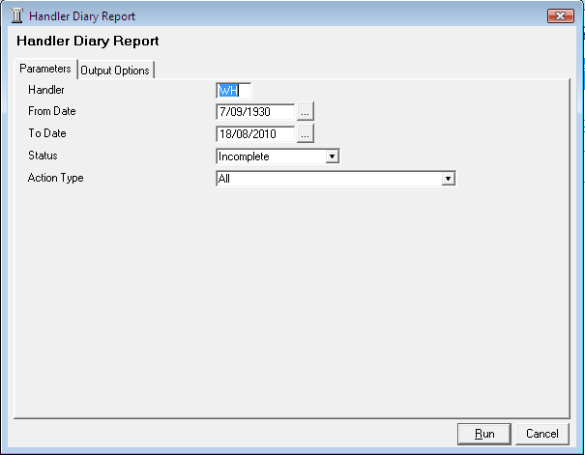

1. Click on ***User Diary Report***. The following window will appear. Specify the following information:

Handler ***Input*** the Handlers initials.

From Date Click on the  ***… lookup button*** and specify a start date.

To Date Click on the  ***… lookup button*** and specify a end date.

Status Click on the ***drop down arrow*** and select complete, incomplete or all tasks.

Action type Click on the ***drop down arrow*** and select the action type i.e. Email, Phone, Dictation, reminder etc.

1. Click ***Run***. The report will generate and appear on your screen.
2. To print click on ***Print***  on the Report Preview toolbar.

### Run User Defined Reports

1. Click on ***Handler User Defined Reports***  on the task toolbar. The following window will appear.

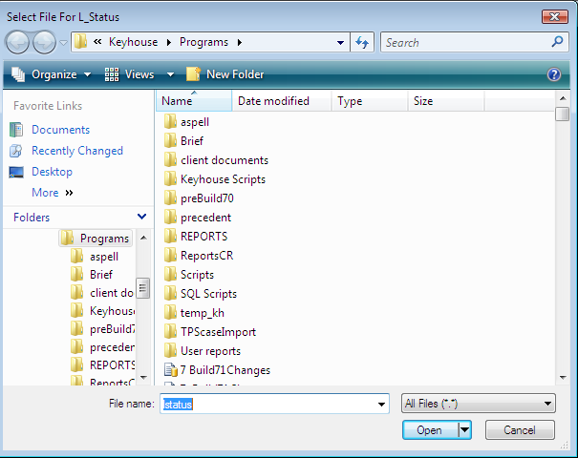

1. ***Browse*** and locate the ***User Reports folder***.
2. ***Select*** the report required
3. Click the **Open** **button**  to run the Report.