Chapter 7: The Document Library

The Document Library allows the user to browse through case plans and to view precedent documents prior to generating. This is helpful if the user is not familiar with the case plan and its documents.

## Searching for a Precedent Document

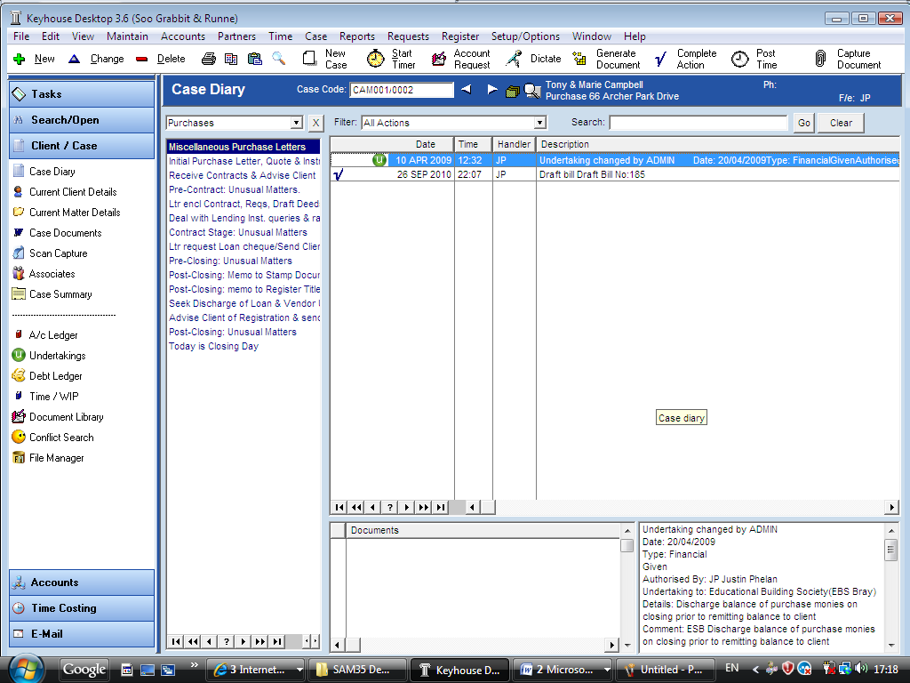

1. Click on ***Client/Case*** on the shortcut bar.
2. Click on ***Document Library*** the following screen will appear.
3. ***Input*** a key search words in the search box provided.
4. 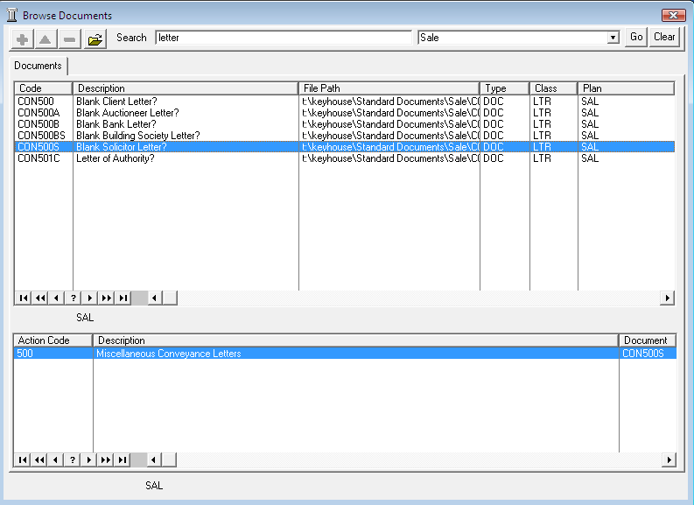***Click*** on the ***drop down arrow*** a list of case plans will appear. Click on a ***case plan***. E.g. Sale
5. Click ***Go***. In the following example the key search word is “letter” and the filter is applied to the “Sale” Case Plan.

To view a document click on the document and then click on ***Open***  located on the toolbar. Word will open displaying the precedent document.

1. Click ***Clear*** to Reset the search.
2. Click ***Close*** to exit the document library